Communications Consumer Panel
& Advisory Committee for Older and Disabled People (ACOD)

Making a Difference for Communications Consumers
Strategic Plan update: 2021- 2022

Contents

Connecting with those who are less likely to be heard in communications sector policy-making 3

Looking forward: Building on our strategic priorities 4

Next steps – our plans looking ahead 8

Connecting with those who are less likely to be heard in communications sector policy-making
Our high-level priorities for our work during the last year have been:
- Ubiquitous availability of communications services
- Excellent standards of service and of customer service
- No consumer ‘left behind’ regardless of circumstances
- Prevention of consumer harm

These individual priorities come together to support our overarching aim of ensuring that the consumer voice was heard - and acted upon - by policy makers. To fulfil this aim, we:
- work with other consumer bodies, industry, Ofcom and governments, and
- inform the debate by conducting research into issues affecting the communications sector.

Who we work with to help deliver what we promise:
We work closely with our extensive network of stakeholders and these relationships, together with our independent insight programme, keep us informed of a wide range of issues in the sector. These issues include not only present forms of consumer detriment but also forthcoming developments that, without intervention, could cause problems for consumers and citizens.

We are grateful for the time and commitment our stakeholders have given to highlighting the issues affecting communications consumers, citizens and micro businesses at a time when digital connectivity and access to a landline and a regular postal service have been valued and relied upon more than ever before.
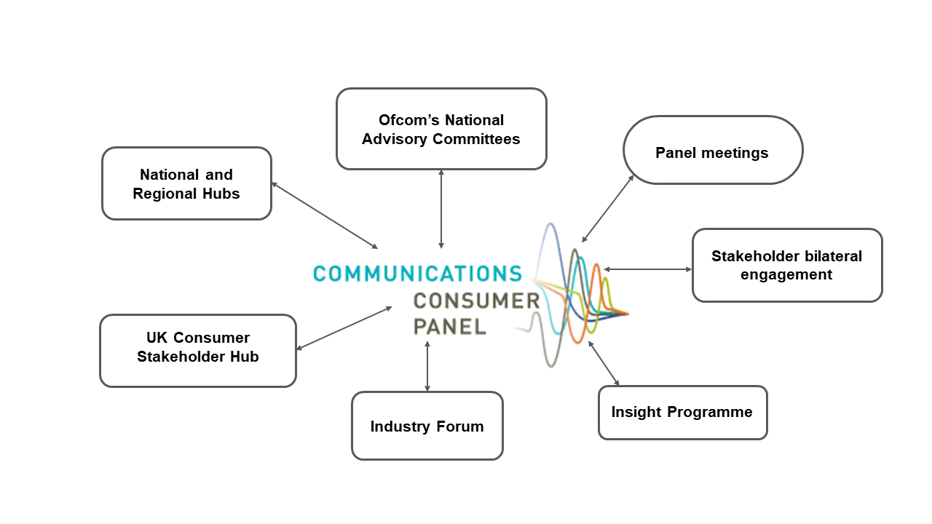

[Diagram 1: The diagram above sets out our two way relationships with Ofcom’s National Advisory Committees, participants at our UK Consumer Advocacy and individual National Stakeholder Hubs, participants at our Industry Forum meetings, presenters who discuss policy with the Panel at our monthly meetings, and stakeholders who we meet with on a bilateral basis.]

Looking forward: Building on our strategic priorities

During the pandemic, the approach we outlined above has proved valuable in terms of making sure we can work to protect and promote the voice of consumers, citizens and micro businesses using the communications sector. We propose to continue to follow these broad themes, updating them slightly to reflect where consumers, citizens and microbusinesses - and the communications sector - stand following the peak impact of the pandemic.
When reviewing our plans and looking at the value the Panel and ACOD can add in the year ahead, we asked ourselves the following questions:
- What have we learned from our work programme?
- What are the future challenges that we can help to address?
- What don’t we know?
Far from slowing our operations, the pandemic has led us to engage more with those working directly with consumers on a daily basis, so that news of impacts could be shared regularly, and timely action taken by regulators, Governments and industry promptly and effectively.
We recently reported to the UK and Devolved Governments on the issues and impacts the Panel has uncovered in the communications sector, and action we have undertaken. We have published the report on our website here.
We have expressed our gratitude to those in industry, regulation and government who have made a direct difference to the lives of consumers, citizens and micro businesses; for their flexibility, prioritisation and resourcefulness at a time of great need. A wide range of consumer, citizen and micro businesses related organisations have engaged with us, including those representing farming and rural communities, older people, young people, racial equality, mental health, carers, people with disabilities and many intersections of the above. This has allowed us to continue to highlight the needs and requirements of consumers, citizens and micro businesses once the initial crisis phase is over. Further details of the insights we have gathered via our National Hubs and our independent research can be found on our website.
The summary below highlights where we believe our strategic plans should remain in place and where they should be updated for the year ahead.

- Ubiquitous availability of communications services

Throughout this period, our programme of enhanced stakeholder engagement and insight gathering has reinforced our view that consumers across the UK need access to basic, secure, affordable, resilient communications services – and they need the skills to use them safely.  - We have urged Ofcom to consider the full range of consumer and citizen impacts of network outages.  We believe that access to communication services should be as much a consumer right as access to any other essential utility.  - We believe that digital skills and participation are a core need for consumers, citizens and micro businesses and plan to engage with stakeholders whose role and core mission is to help to bridge the digital divide.  - We will also continue to use our National Hubs as a way of keeping consumer organisations and charities aware of initiatives that may benefit the people they represent. We will also continue to provide advice directly to communications providers and via policy consultations by Ofcom, governments and others. | Evidence and insights:  Our National Stakeholder Hubs and UK Consumer Advocacy Hubs have clearly voiced this need amongst their constituents. We look forward to continued collaboration with those stakeholders, as well as stakeholders and consumer groups who are not readily identified or hard to reach.
Proposal - retain but expand:
For the reasons explained above, we believe this is an important strategic aim that we must retain. However, we intend to expand it to encapsulate the wider suite of consumer requirements: consumers across the UK need access to basic, secure, affordable, resilient communications services – and they need the skills to use them safely.
- Excellent standards of service and of customer service
We have further strengthened our view that excellent standards of service and customer service are vital for consumers, during, after and well beyond the pandemic.  Stakeholders’ input and our research have supported our view that more can and should be done to make the communications sector inclusive and a frictionless experience for everyone. Consumers with a wide range of access needs and requirements should be able to get the support they need without battling through bureaucratic processes. Communications providers should seek to gain greater insight from their data on complaints, feedback, loss or retention of customers and the impact of network outages – as well as learning from best practice from other sectors and from informed advice and robust research provided by the Panel and others.  We have commissioned research into the experiences of consumers who prefer a specific contact channel for contacting their provider, due to their specific needs or requirements – the findings will be published in the coming months. | This theme has also been voiced clearly by participants at the Hubs.  Our Industry Forum has enabled us to work with the 11 largest communications providers on identifying and serving the needs and requirements of their customers. We look forward to continued collaboration with those providers and others in our aim to develop a consumer charter to inform what consumers can expect from their provider.
Affordability and debt: through our network of Hubs we have heard that consumers have been having difficulty getting through to their provider, in general and specifically when trying to resolve payment difficulties. We know that this has in part been due to the impact of pandemic ‘lockdowns’ on communications providers’ contact centres. However, we have seen positive action from communications providers in preventing disconnections wherever possible. We have urged communications providers to promote their debt and disconnection policies and to be proactive and approachable in terms of identifying and contacting consumers who may be struggling. We are increasingly concerned about ‘data poverty’ and – as we saw in our previous round of research, consumers putting communications service bills before food or utilities. | In 2020/21 we have continued to put forward our recommendations based on the findings of our research Don't cut me off! The customer service experiences of communications consumers living in low income households in the UK.
Proposal: retain
- No consumer ‘left behind’ regardless of circumstances

We have engaged with stakeholders representing consumers who have a diverse range of needs and requirements that are not yet built into mainstream services and systems. What we have been hearing has shown us that there is more work to be done before we can truly say that no-one is left behind in this sector. As a result, we will be focusing even more on consumer and citizen participation in the year ahead and our plan will be amended to reflect this. | Our National Hubs have proven a great way of engaging with stakeholders who represent consumer and citizen needs. Some of our stakeholders have specific needs and requirements that enable them to provide us with insights into their lived experience.  We are keen to see a more proactive and systematic approach to inclusivity, accessibility and usability across the communications sector, so that all consumers feel valued and empowered.
Proposal: retain the spirit of the strategic priority, but merge it with strategic priority one, which covers inclusivity of communications services.

- Prevention of consumer harm – including citizens and micro businesses
Scams:  We learnt from our research into scams and fraudulent activity across communications networks that security, clear communication, action and monitoring (including collaboration and horizon-scanning across sectors) are the four pillars that will help protect consumers from scams and fraud. We heard that some consumers felt ashamed or embarrassed to report scams, some did not believe action would be taken if they did report them and some consumers’ way of mitigating the risk of being targeted in future was to restrict their use of communications services. | We made recommendations to regulators, communications providers and Governments and have met with representatives of consumers, citizens and victims to help inform further action for consumers and citizens across a variety of sectors.
Migration to VOIP/analogue to digital telephony switchover  This is a primary area of concern for the Panel and one where we believe there needs to be consolidated action to prevent consumer harm. Stakeholders have revealed a wide range of levels of understanding of the switchover. | Following discussions within our National Stakeholder Hubs, we have raised concerns with Ofcom, the Broadband Stakeholder Group (BSG) and governments about awareness of the imminent switchover.  We have welcomed collaboration on raising awareness responsibly and continue to work closely with Openreach, the Scottish Digital Office, the Office of the Telecommunications Regulator (the OTA2), communications providers, consumer organisations, telecare providers. We have also commissioned qualitative research which will be published in the coming months.
Proposal: retain

Next steps – our plans looking ahead
We will continue to consolidate the progress we have made in strengthening the consumer voice in the communications sector by facilitating informed discussion, holding industry and the regulator to account and establishing networks of influence to work on behalf of consumers, micro businesses and citizens.
As highlighted earlier on in this document, we believe it is vital that we maintain focus on the strategic priorities that we set out in 2020/21 and drive home further change in those areas.
Having taken into account stakeholders’ views throughout the past year, we would like to update our aims to better reflect the needs and requirements of consumers, citizens and micro businesses in 2021 and beyond.

What we plan to focus on:
- [NEW} Equality of access and usability of communications services that are resilient, secure and affordable;
- Excellent standards of service and of customer service; and
- Prevention of consumer harms.

How we will work towards achieving these aims in the year ahead:

Research
We have recently commissioned research looking at:
- how people’s digital needs have evolved during the pandemic;
- consumers’ preferred channels of contact with CPs;
- issues for consumers during the forthcoming migration to VOIP;
- the needs of consumers living in residential care; and
- the attitudes of consumers who use parcel services.
We will use the findings of each and cross-cutting themes of all of these studies to influence debate and action.

Stakeholder Engagement
We will continue to engage with a wide range of stakeholders, including Ofcom, the National Advisory Committees, other regulators, individual communications providers and other subject matter experts from outside the Panel and ACOD to look deeper into intractable issues that need a more proactive and systematic approach. These include the inclusivity of providers’ services to all consumers, by designing and operating their services, customer services and complaints processes fairly.
National Stakeholder Hubs – we plan to:
Further increase participation across the Hubs and ensure a diverse range of voices are contributing to these discussions;
- Generate and drive evidence-based discussions to feed into emerging areas of policy focus in the communications sector;
- Continue to listen to our stakeholders and drive discussions in response to their intelligence of the issues facing consumers across the UK. We will shortly be circulating a short survey to our stakeholders to further understand where their immediate concerns are; and
- Use the Hubs as a means of gathering evidence for responses to live issues and consultations, encouraging participants to respond directly where relevant.
UK Consumer Advocacy Hub – we plan to:
Continue to share intelligence across the UK, strengthen networks and identify areas that require further research.
Industry Forum – we plan to:
- Conduct further work on defining and understanding ‘vulnerability’. We will encourage providers and regulators to look beyond this label to ensure that consumers with additional needs and requirements can be identified and have an equal opportunity to benefit from communications services ;
- Encouraging smaller providers to join the Industry Forum and benefit from discussions with larger CPs, other sectors and the Panel; and
- Looking forward, encouraging best practice in designing inclusive services so that fewer adaptations are necessary in future.
Panel meetings
Continue to invite external presenters as well as Ofcom policy teams to present their policies, findings and projections to the Panel. This will help us to identify synergies and call out issues of consumer harm, to prevent, reduce or halt impact on consumers and enable proper redress to take place where relevant.

