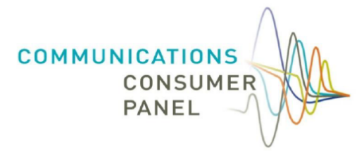

Communications Consumer Panel
& Advisory Committee for Older and Disabled People (ACOD)

Making a Difference for Communications Consumers

What we’ve delivered

Contents

What we’ve delivered 2
Strengthening the voice of consumers, citizens and micro businesses 4
Our Strategic Objectives: Connecting with those who are less likely to be heard 5
Expanding our work to strengthen consumer representation: a summary 6
Research 7
The Panel’s National Hubs 9
Impacts of the National Hub discussions 12
Consumer Stakeholder Hub 14
Industry Forum 15
Next steps – our plans looking ahead 15

Strengthening the voice of consumers, citizens and micro businesses
Central to the Panel’s work is highlighting the interests of people who may not always be heard by the communications industry, or in regulation. We work with Communications Providers (CPs), Ofcom and other policy and industry stakeholders to understand how those interests may best be served, in both the short and the longer term.
In our response to the Department for Business, Enterprise, Industry and Skills’ (BEIS) 2018 Green Paper ‘Modernising Consumer Markets’, we expressed our view that communications services were integral to the everyday lives of consumers, citizens and micro businesses.
We highlighted that the rapid rate of change in this sector and the significance of its role to people’s lives and the UK economy meant that it is vital the perspectives of consumers and micro businesses are at the heart of the debate.
This has never been truer than in the context of the 2020 pandemic. We have been grateful for the opportunity to play our part in representing the consumer voice at an unprecedented time when any communications consumer could become a ‘vulnerable’ consumer – listening to a broad range of consumer, citizen and micro business voices across the UK; and increasing awareness of initiatives put in place by Ofcom, Government and industry to help protect consumers, citizens and micro businesses.
At this time when the resources of charities and not for profit organisations are stretched further than ever, these bodies need as much support as they can to serve their communities. Our increased engagement with stakeholders in the past 18 months has been extremely useful in sharpening the voice of the Panel into industry and regulator. And the role we have played keeping stakeholders informed of communications sector policy has, we’ve been told, been extremely useful to them.
Meanwhile, businesses of all types and sizes have been learning to work more flexibly than ever before - to remain viable, protect their staff and provide continuing services to their consumers. We have heard about the struggles that small and micro businesses have had in relation to moving their work online during ‘lockdown’ and changing business address for an undefined period, all of which comes at a cost.

Our Strategic Objectives: Connecting with those who are less likely to be heard
Our strategic aims for 2020/21, decided after public consultation, are:
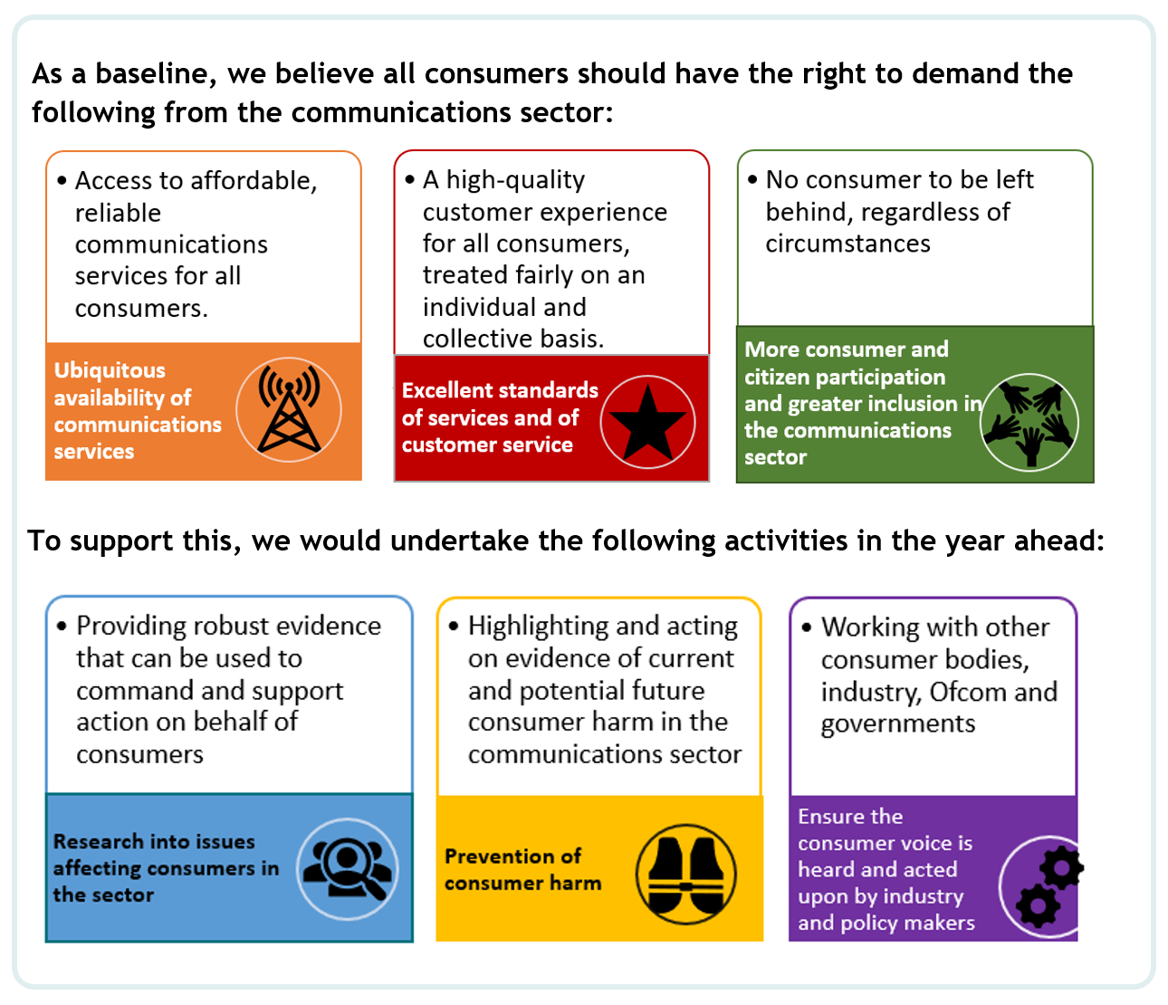

Expanding our work to strengthen consumer representation: a summary
By the end of the year 2019/20, we had put in place all of the initiatives we had proposed to strengthen the consumer voice in the communications sector, and we continue to adapt these to ensure we hear from those who are less likely to be heard in the development of communications policy.
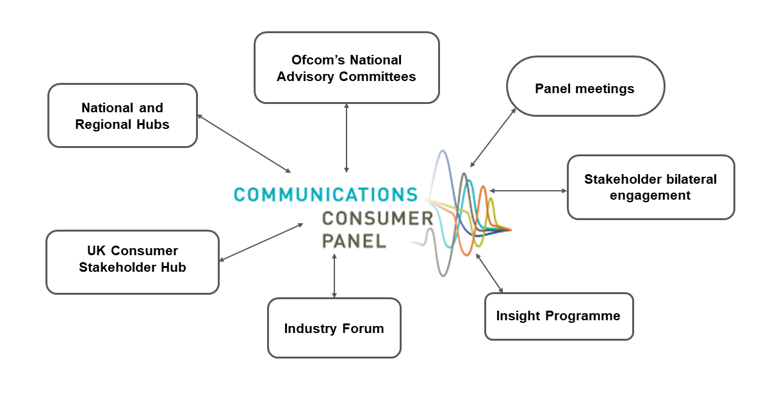We look at each of these initiatives in more depth later in this report, but in summary:
Through our National Hubs, we have been able to deliver on our promises to gain fresh insights about issues affecting consumers, citizens and micro businesses from across the UK - that are particular to each Nation and those that are experienced universally. We have taken those insights to Ofcom’s policy teams and into industry and have seen positive action taken, which we have fed back to Hub participants. We have also acted as a facilitator of debate and encouraged information sharing. We have been pleased that Hub participants have gone on to share research and ideas with other participants following meetings.
A wide range of consumer, citizen and micro businesses related organisations have engaged with us, including those representing farming and rural communities, older people, young people, racial equality, mental health, carers, people with disabilities and many intersections of the above.
Since mid-March 2020, we have held all meetings online. Despite the challenges of virtual discussions, we have seen the positive effect of increased attendance and growth of the membership of our Hubs in all parts of the UK. We have provided access support for participants who need it (e.g. speech to text and captions).
We have worked collaboratively with other consumer organisations – Citizens Advice and Citizens Advice Scotland, the Consumer Council for Northern Ireland and Which? in Consumer Stakeholder Hubs. These have enabled us to learn from those who have direct engagement with consumers on a daily basis, and for all participants to share insights and research plans, so that we ensure that we are working together in a way that makes the most of our differing remits, ultimately further aligning our activities to benefit consumers, citizens and microbusinesses in the communications sector. Outside of these meetings, we meet regularly with participants on a one to one basis to follow up on areas of mutual interest.
We have also been able to work collaboratively with industry, in our Industry Forum. We have brought in a range of speakers from other sectors to raise awareness of best practice that could benefit their customers. We also continue to hold meetings between the Chair and individual communication providers to hold them to account and understand and influence their consumer strategies.
Additionally, we have continued to meet with the two Alternative Dispute Resolution Providers in the communications sector and with the Broadband Stakeholder Group, the Office of the Telecoms Adjudicator, the Phone-paid Services Authority, Digital UK, StepChange and others.
We intend to continue this programme of Hubs and other stakeholder engagement, listening to participants to ensure maintained engagement in the year ahead.
Research
The Panel's role is to influence policy on issues affecting communications consumers, particularly those who may be more vulnerable when engaging with communications markets. Since the start of the pandemic, we are more aware than ever that individuals with very low incomes are particularly vulnerable to sudden changes in circumstances, including job loss/redundancy, loss of a chief wage or changes to benefits. In 2020/21 we have continued to take forward the findings of our research Don't cut me off! The customer service experiences of communications consumers living in low income households in the UK.
We touched on the circumstances of low-income consumers in our publication of Still Going Round in Circles: Complaints handling in telecoms in July 2018, recognising that financial vulnerability can cause telecoms consumers to be negatively impacted.
To gain a deeper insight into these issues, we commissioned PwC Research to undertake a qualitative study in 2019, interviewing consumers across the UK who were classified as potentially financially vulnerable, living on a low income, and who classified themselves as either ‘just about managing’ or ‘genuinely struggling’ to pay their bills. In our cover report, we provide a set of recommendations, grouped under a 'PERFECT' model as established by PwC Research within its research report.
Alongside the wide range of stakeholder engagement that we have also undertaken, we commissioned quantitative and qualitative research into the impact of scams and fraudulent activity across communications networks, on consumers, citizens and micro businesses using or affected by those services.
Fraud or ‘scams’ cost the UK £190 billion a year and are closely connected with other aspects of organised criminal activity. In addition, a third of victims of fraud have suffered a significant emotional or psychological impact as a result.
In this time of COVID-19, people around the world have become ever more reliant on communications services and the key role that they play in people’s lives has never been more evident as we hurtled into new ways of living, working and existing. Yet, at this critical time for UK consumers and micro businesses, it appears that fraudsters have taken the opportunity to increase their scamming activities and exploit people,.
We wanted to understand more about the way scams take place across communications networks (phone, internet, email and post) and the harm they cause to consumers. We previewed the key themes of the research at our National and Consumer Stakeholder Hubs, using it as a stimulus for discussion and raising awareness of activity being undertaken by stakeholders on scams.
Informed by the research, we have made a series of recommendations which we will be pursuing further with industry, regulators and policy makers:
- Security: consumers need to feel that they can use communications services without being afraid of scams;
- Clarity: consumers need to be able to find information on scams easily; if targeted, consumers have a clear way of reporting the scam - they know who to report it to and to be able to do so in a way that suits them;
- Action: consumers have a right to expect that their report of fraudulent activity will be handled compassionately, and action will be taken;
- Monitoring: consumers need agencies to work together to measure and fix the problem and governments should provide the necessary regulatory and enforcement resources to support this.
Members take a particular interest in the needs of older and disabled people and, having heard from stakeholders in their network that apps were not always accessible for people using assistive technologies, we commissioned an audit of CPs’ self-service apps, which we fed back to CPs’ technical teams for follow-up and action. When commissioning the reports, we could not have anticipated the changes in the sector that lay ahead, with the mass closure of retail stores due to the pandemic. We are conscious that many older and disabled consumers rely on these physical stores and will be examining the impact of these changes in forthcoming research.
We also intend to look further into the experiences of consumers with disabilities in the months ahead, to ensure that some of the people who were already less likely to benefit from the market are not disadvantaged or disempowered by the design of policies, processes and services in the post-Covid communications sector.
As mentioned briefly above, we have expanded our research plans this year and will be covering a broader range of subjects, taking insights and recommendations to those who can directly influence change for consumers, citizens and micro businesses and publishing the full reports on our website for access by a range of audiences. Our enhanced programme of insight-gathering has been designed as a way to stimulate debate and share findings with our stakeholder base; in addition to a broader range of market research we will include ‘think pieces’ by experts on key areas of consumer harm in the communications sector, to inform industry and policy makers and help raise standards across the sector.

The Panel’s National Hubs
The Panel’s National Hubs were introduced to help strengthen the UK consumer voice in the communications sector. We have established four Hubs across the UK – one in each Nation. The Hubs have enabled us to increase our impact by capturing the voices of citizens, consumers and microbusinesses across the UK, identifying areas of consumer harm and feeding these back to the regulator and communications providers to help drive-up best practice and improve the experiences of consumers in the communications sector.
The Hubs are chaired by our Nations’ Members:
- Amanda Britain, Member for Scotland
- Rick Hill, Panel Member for Northern Ireland and Panel Chair
- Sian Phipps, Member for Wales (Sian’s predecessor, Karen Lewis chaired the first Wales Hub in December 2019. Rick Hill chaired these meetings until Sian’s arrival in July)
- Richard Spencer, Panel Member for England
Participants
The Hubs have been attended by a wide range of consumer, citizen and small business representatives, including NGOs, policymakers, consumer protection organisations; and a range of charities representing the interests of people who are older; carers; are living with a disability or long-term health condition; are in debt; live in rural communities or are digitally excluded. A full list of those organisations attending can be found at Annex A.
It is important to us that all participants who want to participate, can. We provide speech-to-text support to Deaf participants both online and face-to-face, and endeavour to ensure that all discussions, presentations and communications are inclusive. Ensuring that we have a diverse range of voices and perspectives across the Hubs means that we capture a well-rounded and representative consumer voice, gathering first-hand valuable information from consumer-facing organisations.
The causes of consumer detriment vary and are often just one of several factors causing multiple layers of detriment. By engaging with a wide range of consumer organisations and recognising the part intersectionality plays in society, we can identify and try to tackle the root causes of consumer detriment and have a greater impact. As well as being informed by the views and experiences of our stakeholders, the Hubs also provide an opportunity to learn from them and share insights and updates on areas of work and focus.
Theme-focussed discussions
The National Hubs take place quarterly throughout the year and, following an agreement between participants at the initial Hubs, are thematically driven. To date, topics of focus have been:
- issues facing communications consumers across the Nations - November 2019 to January 2020;
- impacts of the Covid-19 pandemic - March to April 2020;
- consumer impacts of scams and fraudulent activity - June to July 2020; and
- communications issues faced by rural consumers - September to October 2020

- Issues facing communications consumers across the Nations
The introductory Hubs provided participants with information on the Panel and our work, including an overview of the Panel’s research on the types of communications issues faced by consumers in low-income households. An open discussion followed where participants raised pertinent issues facing the consumers they represented in their respective Nations. Participants agreed that moving forward, Hub discussions should be thematically focussed.
- Impacts of the Covid-19 pandemic
The Hubs were due to focus on the affordability of communications services; however, as the circumstances surrounding the pandemic developed, the focus was updated to examine impacts of the pandemic on communications consumers - and how the communications sector could intervene to help consumers during this uncertain time. A summary of our discussions was circulated to our stakeholders, the regulator and published on our website (Annex B). Our discussions were also fed back to communications providers by way of quarterly catch-up meetings and a subsequent Industry Forum meeting.
- Consumer impacts of scams and fraudulent activity
The Panel’s respective National Members provided participants with a preview of our research into scams and fraudulent activity – drawing out the key findings and discussing the types of scams and communications methods used; the circumstances in which people are exposed to fraud; the actions people take after being scammed; and the impacts of scams and how they can be tackled. Many participants were very conscious of these issues and the potentially devastating impacts of scams. They shared their thoughts on where intervention would provide the most impact which helped us to shape and feed-in the UK consumer voice to our research recommendations.
- Communications issues that rural consumers face
The Covid-19 pandemic has amplified consumer reliance on digital connectivity to the extent that communications services are essential for all consumers. To highlight circumstances where consumers may not have the option to carry out the tasks they need to via digital means, we focussed our discussions on rural connectivity and the communications issues that rural consumers face. We heard that many consumers do not have access to a reliable connection; digital infrastructure; the skills required to be digitally active; or the right information to navigate the market and get connected. A summary of our discussions was circulated to our stakeholders, the regulator and fed back to communications providers during quarterly catch-up meetings. We also published a summary of our discussions on our website (Annex C).
The next round of Hubs will take place across January and February 2021 and the discussions will focus on affordability and debt. We will invite speakers to inform participants, spark debate and lead to collaborative recommendations towards positive outcomes.
Response to the Covid-19 pandemic
The inaugural National Hubs were held face-to-face across the Nations in Edinburgh, Cardiff, London and Belfast. We had initially planned to hold the Hubs in various locations across the Nations to capture the range of consumer voices across the UK’s Nations and regions and take account of consumers living in rural areas, in addition to urban. In March 2020, the England Hub was due to take place in Bradford and the Scotland Hub in Glasgow. We responded to the move to lockdown by transferring these meetings to an online platform and we have continued to hold online since the initial lockdown measures were introduced in March 2020. Since moving meetings online, stakeholder engagement has increased and whilst we hope to be able to resume face to face meetings in the not too distant future, we will retain an online provision for people who prefer to attend meetings virtually.

Impacts of the National Hub discussions
Over the past year, our discussions have allowed us to capture the issues facing consumers across the UK. We have incorporated the intelligence gathered, where relevant, into our consultation responses to Ofcom and government on policy affecting communications consumers. It is also important to us that we utilise the knowledge and skills of participants who attend the Hubs and we encourage participants to share updates on recent work that they have been involved in. A number of participants have presented information and research as part of our discussions.
A key example of this collaborative approach concerned specific issues raised at the Northern Ireland Hub and by the Consumer Council for Northern Ireland (CCNI) relating to the potential effects of the implementation of the NI Protocol on parcel deliveries for consumers in NI.
In common with the CCNI, the Panel is concerned that the implementation of the Protocol could create significant consumer detriment and reduce consumer choice by creating barriers which prevent NI consumers from shopping with GB businesses. GB businesses may decide to pass some or all of the additional costs they incur from dealing with the new customs requirements onto consumers in Northern Ireland, or may even decide not to sell to consumers in Northern Ireland at all.
We conducted further analysis of CCNI data which, when examined together with research by Citizens’ Advice and Ofcom, established evidence that suggested that the implementation of the NI Protocol in terms of the proposed changes to the NI customs rules risks a detrimental effect on online shoppers/mail-order consumers with disabilities in Northern Ireland over and above the detriment that may be caused to other NI consumers. We urged HMRC to fully consider the potential consumer issues created by the Protocol and where relevant, take action to reduce or eliminate any consumer detriment. We also urged Ofcom to consider the impact of the revised customs arrangements for second class parcels on the delivery of the Universal Service Obligation both in terms of delivery delays and additional charges. We have subsequently had constructive engagement with both bodies and await news of developments.
The impact on communications consumers of the Covid-19 pandemic
The Covid-19 pandemic has meant that consumers, particularly those in vulnerable circumstances, require additional protections and support. Our discussions have highlighted areas of concern in the communications sector and through discussions with the regulator, communications providers and our stakeholders, we have been able to share these insights, tackling areas of consumer detriment and driving change. We have included examples below.
- Royal Mail postal redirection/diversion – at the beginning of the Covid-19 pandemic, discussions at our Consumer Stakeholder Hub and National Hubs alerted us to the high costs of postal redirection/diversion costs. This was particularly detrimental for small businesses having to move out of multi-occupant business premises in accordance with government measures. For many consumers and small businesses, in a time of financial uncertainty, the cost of redirection/diversion was unaffordable but essential to avoid a loss of custom and income. Not only were the costs high, but Royal Mail also required consumers to sign-up for three months, six months or 12 months with cost reductions for longer periods of time. This was particularly problematic for consumers as during the initial National lockdown, there was no clarity on how long the restrictions would last. The Panel raised this issue with the regulator and Royal Mail, drawing on the need for them to respond to businesses’ difficulties during an uncertain and troubling time. Although the Panel was pleased to hear from Royal Mail representatives that customers would be offered refunds for any unrequired months, we remained concerned that the upfront cost for the service remained high. We are therefore pleased that Royal Mail has now launched a small business diversion service for businesses with fewer than 50 employees at a much reduced cost.

- Ofcom’s Stay Connected Guide in Easyread – the Covid-19 pandemic and UK Government’s announcement that there would be a national lockdown demonstrated how essential universal digital connectivity and reliable communications services had become for consumers for a wide range of day-to-day activities, for example speaking with friends and family; using public services; working from home; food shopping and accessing healthcare. Ofcom launched a helpful ‘Stay Connected’ campaign, offering connection tips to communications consumers. We welcomed this campaign and shared the information with our stakeholders but noted that some participants raised concerns that Ofcom’s campaign might not be accessible to consumers with low-literacy levels. The Panel suggested to Ofcom that an Easyread version would help to overcome this barrier and we were pleased that Ofcom responded, publishing an additional Easyread version on its website.

- Availability of Text Relay UK – The pandemic meant consumers could not access services face-to-face, instead having to rely on telephone or online services. For d/Deaf and speech-impaired consumers who do not access services online, telephone services would have been their only option. Participants of the National Hubs raised concerns that D/deaf and speech-impaired people were experiencing longer than average waits to access Relay UK for regular calls. The Panel raised these concerns with Ofcom colleagues, who were aware of the issue and provided a written statement that the Panel published on its website.

- Use of British Sign Language interpreters during UK Government live broadcasts – the pandemic has reinforced the importance of public service broadcasters as trusted providers of news and information. At the initial stages of the pandemic, information was largely accessed through live daily televised updates on the BBC. We heard from Hub participants that live BSL interpretation was not consistent across broadcasters and was absent during UK Government’s daily live updates, but was available during updates from the devolved governments. The Panel raised these concerns with Ofcom colleagues, and we are pleased to note that BSL interpretation are now present during UK Government live broadcasts.

- Migration to VOIP/all-IP networks
- we have been alarmed by the low awareness among Hub participants of the significant upcoming change to the telephony network that is due to take place by 2025. This will particularly have an impact on landline-only users and users of special services such as telecare alarms. The Panel has raised its concerns with the Broadband Stakeholder Group, Ofcom, the Office of the Telecoms Adjudicator (‘OTA2’), communications providers and Openreach. We believe it is vital that organisations supporting vulnerable consumers have the information they need in time to protect vulnerable consumers, citizens and micro businesses.

Consumer Stakeholder Hub
The Consumer Stakeholder Hub provides an opportunity for consumer advocacy bodies to come together and share knowledge and awareness of the types of issues facing consumers nationally. It was established to help strengthen the consumer voice in the communications sector by working in conjunction with the Panel’s National Hubs and Industry Forum. Regular attendees include: Citizens Advice, Citizens Advice Scotland, Consumer Council for Northern Ireland and Which?. The meetings provide an opportunity to share knowledge across the consumer landscape and drive awareness of any ongoing work/or research and avoid duplication of work. The meetings have been held quarterly since January 2020 (except for during the initial stages of Covid-19 pandemic where meetings were held monthly). These discussions were invaluable during the initial stages of the pandemic to share intelligence in a fast-paced and unpredictable world where consumers needed additional protections.

Industry Forum
Our Industry Forum gathers the larger communications providers together under Chatham House Rule. The Panel’s Industry Forum meetings are chaired by Rick Hill MBE, Chair and facilitated by Panel Member Kay Allen OBE.
The Forum enables discussion of how to overcome obstacles and barriers to service improvement – including making their services accessible and easy to use by all consumers– notwithstanding the fact that they are competitors of each other. Our aim is to provide a baseline level of fairness for consumers, above which CPs can freely compete for customers. In the first instance, we support Ofcom’s aim of ‘Making Communications Work for Everyone’ and to provide examples of best practice in other sectors to help inform CPs about methods to overcome barriers to this goal.
We have invited speakers from financial and payment services and the utility sector, as well as Ofcom, to speak to the Forum about the ways vulnerability can be measured– including financial vulnerability - and the services and concession that can be provided to support all consumers, regardless of their circumstances.

Next steps – our plans looking ahead
We will continue to consolidate the progress we have made in strengthening the consumer voice in the communications sector by facilitating informed discussion, informing industry and holding it accountable and establishing networks of influence to work on behalf of consumers. Our next steps include:
Research
We are currently scoping research looking at how people’s digital needs have evolved during the pandemic; consumers’ preferred channels of contact with CPs;, issues for consumers during the forthcoming migration to VOIP; the needs of consumers living in residential care; and the attitudes of consumers who use Royal Mail’s parcel services.
National Hubs
- Increase participation across the Hubs and ensure a diverse range of voices are contributing to these discussions;
- Generate and drive evidence-based discussions to feed into emerging areas of policy focus in the communications sector;
- Continue to listen to our stakeholders and drive discussions in response to their intelligence of the issues facing consumers across the UK. We will shortly be circulating a short survey to our stakeholders to further understand where their immediate concerns are; and
- Utilise the Hubs as a means of gathering responses to live issues and consultations.

Consumer Stakeholder Hub
- Continue to share intelligence across the UK, strengthen networks and identify areas that require further research.
Industry Forum
- Further work on defining vulnerability and ensuring that consumers with additional needs can be identified and helped easily in a crisis – working with Ofcom to incorporate this into its guidance;
- Encouraging smaller providers to join the Industry Forum and benefit from discussions with larger CPs, other sectors and the Panel; and
- Looking forward, encouraging best practice in designing inclusive services so that fewer adaptations are necessary in future.

https://www.communicationsconsumerpanel.org.uk/downloads/modernising-consumer-markets-response-website-040718.pdf
https://www.communicationsconsumerpanel.org.uk/news/latest/post/749-our-new-research-on-scams-has-been-published
The Police Foundation December 2018
BBC article on romance scams: https://www.bbc.co.uk/news/business-52664539
Action Fraud article ‘UK Finance reveals ten Covid-19 scams to be on high alert for: https://www.actionfraud.police.uk/news/uk-finance-reveals-ten-covid-19-scams-the-public-should-be-on-high-alert-for
https://www.communicationsconsumerpanel.org.uk/downloads/ccpscammeddecember2020.pdf
https://www.communicationsconsumerpanel.org.uk/news/latest/post/745-ofcom-has-responded-to-reports-that-deaf-and-speech-impaired-people-are-experiencing-longer-than-average-waits-to-access-relay-uk-for-regular-calls
https://www.ofcom.org.uk/__data/assets/pdf_file/0010/200503/media-nations-2020-uk-report.pdf

