The impact of using an alternative channel to get in touch with communications providers
Research Report
June 2021

Contents

1. Background and Approach 3
1.1 Background 3
1.2 Research approach 3
2. Executive Summary 7
2.1 Implications for Ofcom 13
3. Findings in depth 16
3.1 Drivers of channel preference 16
3.2 Overall channel preferences 27
3.3 Recent contact with providers and the incidence of customers not being able to use their preferred channel 29
3.4 Impact of not being able to use the preferred channel 37
4. Implications and key considerations 56
4.1 Implications 56
4.2 Key Considerations 59
5. Appendix 63
5.1 Background and Approach 63
5.2 The quantitative survey 64
5.3 The qualitative research 65

Background and Approach

1.1 Background
The Communications Consumer Panel carries out research, provides advice and encourages Ofcom, Government, the EU, industry and others to look at issues through the eyes of consumers, citizens and small businesses. The Panel pays particular attention to the needs of older people and people with disabilities, the needs of people in rural areas and people on low incomes, and the needs of small businesses, which face many of the same problems as individual consumers.
The Panel is often described as a ‘critical friend’ to Ofcom. It provides robust and independent advice that is constructive, realistic and cognisant of the trade-offs that regulatory decisions often involve. This is made possible by the fact that Ofcom shares information and ideas with the Panel early in the regulatory process before consulting formally with other stakeholders.
The context for this programme of research is the coronavirus pandemic. The pandemic has prompted changes in the way people engage with the telecoms industry, with a general push online as some contact centres and face-to-face outlets have been forced to close. This is likely to have left some audiences unable to use their preferred means of contacting providers. The Panel was particularly interested in the impact on people who might have additional requirements due to their circumstances, including those who have recently become vulnerable due to the impact of Covid 19.

1.2 Research approach
A quantitative and qualitative approach was taken among audiences across the UK.
1.2.1 Quantitative survey
Fieldwork was predominantly conducted using the random-probability NatCen Panel. The NatCen Panel is formed of people recruited from the British Social Attitudes (BSA) survey, a high-quality, random probability survey.
The total achieved sample of 5,079 interviews was made up of:
- Interviews with 4,979 panel members: of whom 4,777 (96%) completed the survey online and 202 (4%) completed the survey on the phone.
- Interviews with 100 people living in Northern Ireland conducted via telephone. Quota sampling was used, with quotas set based on gender and age group.
This element of the research provides, across the UK adult population, a robust measure of;
- The extent and type of contact that customers have had with their communications providers over the 6 months prior to the survey taking place, and the reasons for this contact
- The extent to which customers were or were not able to use their preferred method of contact
- The impact of not being able to use their preferred method of contact on the service experience and outcome of the contact customers had with their provider.
1.2.1 Qualitative research
This comprised 21 in-depth interviews with individuals who had been in touch with a communications provider in the last 6 months and had been unable to use their preferred communication channel to do so.
Quotas were imposed to ensure a good mix of participants by gender, age, reason for getting in contact, service contacted about and provider contacted.
Interviews were conducted across all nations in the UK and also across urban, suburban, rural and remote rural locations.
Participants were recruited to have a range of different characteristics or conditions that might result in them having additional requirements when contacting a provider. Some of the customers recruited had more than one condition or characteristic that made them eligible for the research.
Across the 21 interviews as a whole, customers had the following mix of characteristics:
Characteristics or conditions that may result in customers having additional requirements
Those with financial difficulties | 10
Those with reduced hours/furloughed/redundancy due to Covid-19 | 3
Older (75+) | 8
Physical impairment | 7
Mental impairment | 4
Low digital literacy; not confident using the internet | 5
Low literacy/numeracy | 4
English as a 2nd language | 1

With the exception of those with financial difficulties and those that had their hours reduced / had been furloughed / been made redundant due to Covid-19, participants were also recruited as lacking confidence when dealing with providers.
The above list of conditions and characteristics were self-defined by research participants using a series of agree/disagree statements. Further details on these can be found in the Appendix.
The qualitative research provides examples of what can happen when customers, especially those who may have additional requirements, are unable to use their preferred contact channel.
This report details the findings from both the qualitative and quantitative elements of the research. Full details of the research approach, including a description of the interviewing methods adopted, are provided in the Appendix.

1.2.2 Quantitative Survey Audience Definition
When documenting the results of the quantitative survey throughout the report, we refer to customers with potential additional requirements (PAR customers) and customers who are less likely to have potential additional requirements (Non-PAR customers).
Customers with potential additional requirements are people who have one or more of the following conditions or characteristics:
- 75+
- Use the internet infrequently
- Find things very difficult financially
- Have a physical or mental long-term impairment that impacts their ability to undertake daily activities.
These are characteristics deemed likely to result in a customer potentially having additional requirements when contacting a provider. At some points in the report these customers groups are looked at individually, and at other points they are looked at collectively as a sub-group called PAR customers.
Non-PAR customers are those without any of the above characteristics.

Executive Summary
Outlined below is a summary of the key findings emerging from the research, followed by some potential implications.
Customers have a range of needs when contacting providers.
Among customers with additional requirements (i.e. those customers with conditions and characteristics deemed most likely to result in a customer potentially having additional requirements when contacting a provider) there is a spectrum of needs from those requiring more reassurance and practical support to those that are looking for maximum convenience and control.
- The reassurance and practical support seekers tend to be least confident overall and are looking for a ‘human’ experience, where they are provided with advice, help and support from an empathic individual who tailors the service to their needs.
- At the other end of the spectrum, the convenience and control seekers are more transactional in their approach. They are seeking speed and convenience from any interaction and can be more digitally skilled (or at least more familiar with using technology) so are better able to ‘self-serve’. Some in this group are actively avoiding a human experience, in that they prefer to keep any in personal interaction with providers to a minimum.

Channel preference tends to be driven by a combination of customer needs and the ability to access channels; therefore there is no ‘one size fits all.’
There is a combination of factors that can drive channel preference:
- Reassurance and practical support seekers are typically more drawn towards in-store or telephone (if an in-store option is not available or accessible). Control and convenience seekers tend to be more drawn to online/email or telephone (if online/email are either not suitable or not on their radar as a potential channel).
- There are also practical considerations, driven by personal preference, for some customers making it more or less practicable to access different channels. For example, face to face is the ‘gold standard’ for some, although it feels inconvenient and more difficult to access for others. Webchat/website forms are the quickest and most convenient form of contact for some but others have conditions or characteristics that mean they struggle to use them.
- Some contact channels present a physical barrier for people with some of the characteristics outlined previously in this report. This can limit their options and choices, making using an alternative channel more difficult or stressful.
  - The depth interviews show that having a mental health condition can either drive customers towards having an increased need for reassurance and practical support, or towards having an increased need for control and convenience. Either way, being pushed to a non-preferred channel and forced to change from their usual modes of contact with a particular provider can be highly stressful for those with mental health conditions.
Having physical barriers can also make some channels more difficult to use.
- For example, those with dexterity impairments reported that they would find it difficult if they felt they were being pushed towards using online or email communication."
  - Having low digital skills tends to move customers towards seeking reassurance and practical support. This means that in-store tends to be the preferred channel (if available), or telephone if there is no in-store option. Being pushed towards telephone from in-store can be challenging for those with low digital skills, particularly if they are required to follow instructions or discuss anything involving ‘technical’ terms. Being pushed from telephone to webchat can be even more difficult as it may be an unfamiliar way of communicating, and requires typing skills.
  - Participants who self-identified as having lower levels of literacy/numeracy or cognitive difficulties than average can also move customers towards seeking reassurance and practical support, so towards in-store if available or towards telephone if there is no in-store option. Moving to a channel that offers less support than they are used to can be highly stressful for these customers. Amongst those who struggle to follow instructions, there are some younger customers who prefer the control of online tools as these enable them to follow instructions at their own pace.
  - Having hearing loss tends to drive customers away from telephone towards in-store if available or to online/email if not. Being driven to telephone can be very difficult for these customers as they struggle to understand, meaning they often lack confidence that their issue has been adequately resolved.
  - Having a strong accent or struggling to understand strong accents also tends to drive customers away from telephone towards in-store if available or to online/email if not. Being driven to telephone can be very difficult for these customers as they struggle to understand, meaning they often lack confidence that their issue has been adequately resolved.
- Finally, channel preference can also be driven by awareness and familiarity with the channels available, particularly when it comes to webchat and website forms.

Those with the strongest channel preference tend to struggle most with having to use a non-preferred channel
Customers with the strongest channel preference may put off dealing with less critical issues until the preferred channel is available (this largely applies to those with a preference for face-to-face) or delay getting in contact and so the issue stays unresolved for longer.
- Almost half (46%) of customers who have contacted a provider over the past 6 months have been unable to use their preferred method of contact at some point.
- When unable to use their preferred channel, customers tended to pick the one they see as next best able to meet their needs. For example, if they are looking for reassurance and practical support and they can’t access stores due to them being closed as a result of the pandemic they are most likely to use the telephone.

Using a non-preferred channel can have a significant impact on outcomes, for all customers, but for customers with potential additional requirements in particular.
On their most recent contact, one in five customers with potential additional requirements who communicated via a non-preferred channel had to give up because they were unable to get the help they required.
- In the quantitative research, customers with additional requirements are more likely than customers without additional requirements to report that their provider interactions have been longer, more stressful and more difficult than usual during the pandemic.
- If they haven’t been able to use their preferred channel, their experience has deteriorated further.
- It is apparent from both the qualitative and the quantitative research that when customers are unable to use their preferred channel it takes longer, leads to higher levels of stress, and poorer outcomes.
- Almost half (47%) of customers with additional requirements communicating via a non-preferred channel were unable to get the information or outcome they wanted on their most recent contact. This is significantly higher than both customers with additional requirements using a preferred channel (31%) and customers without additional requirements communicating via a non-preferred channel (35%)
- We also know from the qualitative research that customers are more likely to put off getting in touch to resolve issues, so they go on for longer than they should.

If face-to-face options are not available some customers can find contacting providers particularly challenging.
From the qualitative interviews it is apparent that the ‘reassurance and practical support’ seekers forced to use an alternative channel due to non-essential retail (e.g. mobile phone operator outlets) being closed as a result of the pandemic are most likely to struggle.
- Some, less confident customers feel they achieve better outcomes in store:
  - It is seen as easier for staff to recognise face-to-face that customers may have a condition or characteristic that can make contacting a provider more difficult. Customers are therefore more confident that staff will be able to adapt the service experience to their needs.
  - It is also believed to be easier to communicate, including building a rapport, with staff face to face. Establishing a rapport can be valuable in reassuring the less confident and also making it easier for them to inform the provider if they are struggling and/or have any additional requirements.
  - When required to use an alternative channel, these customers are more likely to come away from the contact either with their issue unresolved or unsure whether they have achieved it.

- Some customers also require more practical, hands on, support.
  - In store, they can be shown how to do something, or it can be done for them if they are struggling. Being able to handle mobile handsets reassures them that the handset selected will meet their needs.
  - Similarly, some customers are reliant on an engineer visit to fix their issue where they might struggle themselves. This is particularly the case where they have mobility or dexterity impairment but also for those with the lowest levels of digital confidence. Customers (particularly those who are experiencing financial hardship) can be discouraged by concerns that they may have to pay for an engineer call out charge, even though they would benefit from an engineer coming out. Alternatively, restrictions during the Covid-19 pandemic could make accessing an engineer more difficult.
  - As a result, they can find it hard to resolve issues or may delay addressing them until practical support becomes available.

The telephone is the default channel for many; however, long waiting times are causing frustration and anxiety.
Customers tended to report that wait times, amongst all providers including communications providers, have increased during the Covid-19 pandemic. This is perhaps not surprising given that the quantitative findings show that the telephone is both most likely to be the preferred channel (used by 62% of all customers contacting their provider) and also tends to be the default option if a preferred alternative channel is not available.
There are a number of reasons for the popularity of the telephone as a contact channel, in particular:
- When handled correctly the telephone can serve the needs both of those seeking reassurance and practical support and those looking for convenience and control.
- As a channel, it is top of mind and readily available from all providers. It is also easy to access, including for those with lower mobility and for those with limited dexterity and/or low digital skills.
However, long wait times cause frustration and increase anxiety, and this is especially true in the absence of any information about how long they can expect to wait. Customers can feel pushed to a non-preferred channel which can result in increased stress and a poorer outcome. Alternatively, they can persist with the contact but then enter the call with heightened levels of anxiety which can make it harder to focus and achieve the outcome they need.
Over and above wait times, there are also other aspects of the telephone experience which can make it harder to achieve successful outcomes for some customers with additional requirements.
There are a number of reasons why the telephone may not work for some customers with additional requirements:
- Those with anxiety can find the telephone exacerbates their condition, particularly if required to wait or be put on hold for extended periods.
- Lack of empathy from the call handler. Linked to the above point, it was clear that customers with additional requirements often felt that call handlers didn’t take account of their needs (e.g. There were instances where call handlers talked too fast or made use of ‘jargon’) which could unsettle them. Call handlers often did not seem to identify that the person they were talking to had additional requirements.
- Anyone with hearing loss can find it particularly difficult to hear on the telephone without the visual cue of seeing someone talking.
- Those who have difficulty understanding strong accents and/or with strong regional dialects themselves can also struggle to be understand and/or be understood.
- Customers can find it hard to make comparisons between different options over the telephone, because of the volume of information they need to process and/or not being able to see the available options.
- It can be difficult for some audiences to carry out instructions on the telephone when calling to repair a fault or requiring practical help. This can either be due to physical impairments, making it hard to perform the tasks required, or cognitive impairments, making it hard to follow what they are being asked to do.
Some customers with additional requirements noted that they could find themselves disregarding their initial objective and simply trying to leave the call to avoid further stress or embarrassment.

Online (webchat/website forms) currently seems to be under-utilised as a channel due to lower levels of awareness and familiarity.
Not everyone is aware of online as a channel or are familiar with how it works (e.g., many are not aware that there is often a ‘real person’ at the other end rather than an automated response).
These customers effectively do not have the option of these channels, which may have the potential to meet their needs.
- Customers using webchat for the first time, where a chat handler was responding, are often pleasantly surprised by how interactive and ‘human’ the experience is. In particular, they report that it feels like a ‘real’ conversation and the chat handler can come across as friendly and helpful rather than the ‘robotic’ experience that they feared.
- Having a written record of the contact can be reassuring.
- It can also work better for those that struggle with accents and/or who prefer to be more in control during the contact, so they can go at their own pace.
However, it is not for everyone. For example, it is not suited to those with very low digital skills/confidence or those who find typing difficult.
- Lower levels of familiarity with how it works also means customers are dependent on the chat handler to put them at ease and guide them through the chat. Customers can become unsettled by any extended delays in the conversation (e.g. If the chat handler takes a long time to respond to a question) and may give up or become (more) anxious.

When not using their preferred channel, some customers tend to be less confident going into the contact which makes achieving a positive outcome more difficult.
From the qualitative research it is apparent that customer confidence in dealing with providers seems to have a significant impact on successful outcomes. Due to the technical nature of the contacts, less confident customers seem to struggle more to understand what is being discussed and are more likely to give up before they have (fully) resolved their issue.
Where customers become stressed and anxious during a contact it can make it harder for them to manage the interaction successfully. As a result, they are more likely to come away with an outcome that does not fully suit their needs or with their issue(s) unresolved.
Customers’ lack of confidence can be exacerbated by:
- Robotic and/or highly scripted service experiences. This can be on webchat, if the query seems to be being answered by a chatbot and you find yourself going around in circles, as well as on the phone, if the call seems overly scripted. In both these instances, customers can struggle to get their issues resolved unless they are prepared to persist. This requires a degree of cognitive and emotional effort that not all are able to expend.
- Feeling out of control. This includes being uncertain as to why they are waiting, how long they will have to wait or what is happening next. It can also be caused if they don’t feel they have been given sufficient opportunity to express themselves.
- Being uncertain about the outcome of the contact. Customers can leave a contact not totally clear about what has been agreed or whether their issue is resolved, this is particularly an issue for those that are used to a written record either from the web chat or a printout in store.

2.1 Implications for Ofcom
There are a number of potential implications arising from this research for both Ofcom and providers, further details on which can be found in Section 4.1. A summary of these has been included below. These are based on findings emerging from the research.
Implications for Ofcom
1. It is important for the full range of contact channels to be maintained to reflect varying customer needs, as it can be harder for customers with additional requirements to achieve a positive outcome when preferred channels are not available. This can result in customers either:
- Failing to resolve their issue,
- Coming away from the contact uncertain as whether their issue has been resolved or they have achieved the best outcome,
- Or giving up and having to delay resolving their issue until another time.
2. Some customers are more confident and feel they get better outcomes when dealing face-to-face. Alternative channels need to deliver as closely as possible on the valued benefits of face to face contact.
3. It becomes even more important for providers to consistently follow Ofcom’s ‘Treating Vulnerable Customers Fairly’ guide when customers with additional requirements are unable to use their preferred method of contact. In particular, it is apparent that providers can struggle to identify customers who may have additional support needs when not dealing face to face.
4. Long wait times on the telephone can push customers into other, non-preferred, channels and/or increase levels of stress and anxiety.
Implications for Providers
1. Customers are highly reliant on service agents adapting services to their individual needs. This is true at all times, but when certain contact channels are unavailable, customer services agents are more likely to be exposed to customers who may find alternative channels more challenging. This can include requiring more reassurance to reduce levels of anxiety and improve their chances of a successful outcome.
2. Anxiety levels can also be reduced by managing customer expectations during a contact - for example, around what is happening next or around likely wait times.
3. When face to face options are not available, providers may need to be mindful that some customers will require more practical, hands on, support.
4. Customers who are using a channel they are less comfortable with can be less confident in the outcomes they receive. This is particularly an issue for telephone contacts, where it is felt to be more difficult to obtain written confirmation of what has been agreed compared to an in-store or online contact.
5. Webchat can be an effective alternative for some customers but is being underutilised as a channel at present. However, providers also need to be aware that webchat and website forms will not work for all audiences.
6. Providers need to be mindful of communication barriers when using the telephone. This can impact on the customer’s ability to get the outcome they needed.

Findings in depth
This section describes:
- The drivers of channel preference
- Overall channel preferences
- Recent contact with providers and incidence of customers not being able to use their preferred channel
- The impact of not being able to use their preferred channel on the customer’s contact experience
- The impact of not being able to use their preferred channel on the customer’s outcomes.
Each of these issues in described in the subsequent sections in turn.

3.1 Drivers of channel preference
Channel preference is driven by three key interrelated factors. These are:
- Awareness; customers have differing levels of familiarity with the available channel options
- Needs; customers have different needs from the contact experience which range from reassurance and practical support to convenience and control
- Ability to access; some customers have characteristics or impairments that make some channels more or less easy to access.
How these factors interact within one customer to produce their individual channel preference is not straightforward, and so not easy to predict. What is more, strength of channel preference is variable and may also differ depending on the nature of the issue.
Each of these factors is described in greater detail in the following sections.
3.1.1 Awareness of the available channel options
Customer familiarity with the available channel options is variable. Taking each channel in turn:
Telephone
All customers participating in the qualitative interviews are aware of telephone as an option and all have used it at some point when contacting a provider. Indeed, for many this is their ‘default’ contact channel; the one that is most top-of-mind when the need to contact a provider arises. For many customers telephone is a convenient and readily available option; the required telephone number is generally easy to find via Google or on an old bill and their phone is seldom far away.
In-store
Again, all customers are aware of this as an option but they are also aware that only certain providers have a bricks and mortar channel. In-store is strongly associated with mobile providers, and some customers also associate it with broadband. Those who prefer this option may be unable to use it for all contact, either because it is not offered by the provider, because they live too far from a store and/or because they are not sufficiently mobile to access this channel without assistance.
Online (webchat or website form)
Among the customers interviewed in the qualitative research, there are lower levels of familiarity with, and experience of, webchat or website forms as channels that are available for contacting a provider. Some customers are unaware that these options exist at all.
Among customers who are aware of online as an option, it can feel slightly less convenient than telephone given the need to go onto the provider’s website and find the webchat or website form.
Other customers who are aware of online as an option don’t fully understand how it works and are not aware that they may be chatting with a ‘real’ person, assuming instead that they are (or would be) chatting with a robot.
However, some of the customers we spoke to in the in-depth interviews are regular users of and have a clear preference for online contact.
Email
The interviews suggest that the majority do not consider email as an option when contacting a provider; it is not top of their mind for most as a possible channel.
Among the few who do use it as a channel, it is often a second option when telephone has proved difficult. Occasionally it is mentioned as a preferred option by those who struggle to communicate by telephone and who are unfamiliar with webchat as an option.
Some have considered it but rejected it on the basis that they do not know how long it would take to receive a response.
App
Using an app to contact a provider is rarely mentioned in the in-depth interviews. It appears that most customers are either unaware of being able to contact a provider via their app, or, if aware, have not used it frequently enough to form a strong view about it.
However, the few who do use this channel regularly are very positive about it, describing it as easy, convenient and easy to access once they have downloaded it onto their phone. It is seen to work well for simple queries such as looking to obtain your balance.
It can be concluded from the above that in reality, many customers are not choosing freely across the full range of channel options offered by providers. Rather they are choosing from a narrower range of options: those available from the provider at the time they need to make contact and ‘top of mind’ for them when the need to contact a provider arises. Convenience and habit play a big part in channel choice.
3.1.2 Customer needs when contacting a provider
Customers of all types sit along a spectrum of needs when contacting providers. At one end of the spectrum there are the ‘reassurance and practical support seekers’ and at the other end there are the ‘convenience and control seekers’. These two customer groups, or ends of the spectrum, are described below.
Reassurance and practical support seekers
These customers tend to be the least confident overall when contacting providers.
They are more relational in their approach to providers. As a result, they are seeking a more ‘human’ experience when they connect with a member of staff, hoping they will be empathic and helpful in their approach to dealing with customers.
“Oh [seeing a face] gives you everything. A face tells you a million things. It’s the expressions, you can read so much into a face.” Female, 74, mental disability, low digital skills
They tend to be looking for relatively high levels of support from the member of staff in resolving their issue and so;
- If they are in the process of taking out a new contract or getting a new phone, they will be seeking advice and/or explanation from the staff on what options might be suitable for them in these areas
- If they have a technical issue to be resolved, they are looking for someone to fix the problem for them; either they lack confidence in their own abilities or they may not have the manual dexterity/physical mobility to fix issues themselves
- In all instances, they are keen to rely on the ‘technical expertise’ of the customer service agent, as they tend to feel they lack technical expertise themselves
- They are seeking reassurance from the staff member that the issue has been resolved.
“I’m not that confident, I just want to explain the situation and expect them to be the experts and sort it out. Maybe I should be more assertive [on the phone] in getting them to fix problems, I don’t know.” Male, 74, low digital skills
Convenience and control seekers
Customers at this end of the spectrum are more transactional in their approach to providers. They prefer to limit their contact with providers and are happy to trade off some of the additional reassurance that speaking to someone would provide, with speed and convenience.
They tend to be more technically competent, or at least reasonably familiar with technology, so are less reliant on receiving advice, support or reassurance from a customer service agent. They tend also to be more ‘self-serve’, in that they are more likely to know what they want to achieve from the contact and wish to resolve their issue quickly.
These customers can find the experience of a telephone call stressful, especially if there is a long wait time, and can therefore be keen to avoid this channel.
Some customers at this end of the spectrum are actively avoiding a human experience and this includes those who find talking to someone they don’t know stressful, those who struggle to hear and/or struggle with accents on the phone, those who can find themselves feeling under pressure to respond quickly on the phone rather than taking the time they need to think and/or follow instructions, and those who are worried about getting talked into things by a customer service agent, even if it is not what they actually want.
“I prefer livechat because it is less time consuming and more on my terms … I can control how quickly I respond and actually come out of it if it’s not the right time, so It’s a bit easier” Female, 31, Financially vulnerable
These differing needs often drive the customer’s choice of channel. Reassurance and practical support seekers are more drawn to face-to-face, or telephone if face-to-face is not available. Convenience & control seekers are more drawn to online if they are familiar with this option, or the telephone if they are not.
This is illustrated in the diagram below, which also highlights that for customers at both ends of the spectrum, telephone is their second-best option should their preferred option not be available or possible.
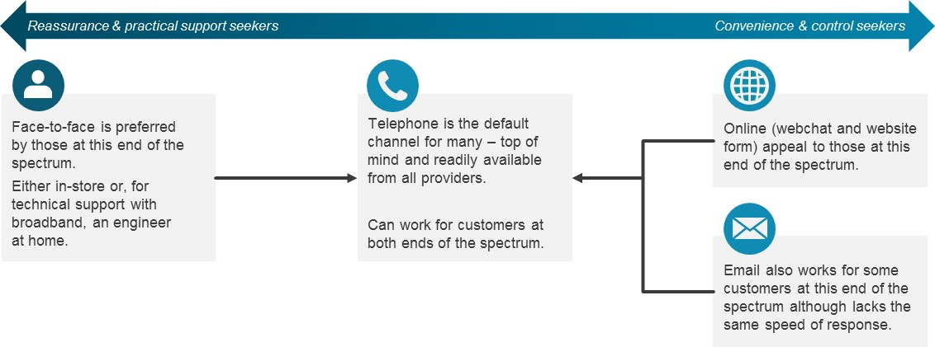

Each of the available channels has a different set of perceived features, which appeal to a greater or lesser degree depending on where a customer is along the spectrum.
In-store
For most reassurance and practical support seekers, in-store is the ideal channel - the ‘gold standard’.
Being able to engage face-to-face with a member of in-store staff helps the customer feel at ease. Customers also feel that the member of staff is better able to see and understand any additional requirements they might have.
“Online I’d rather not go to, I’m not an online person. I’d just be in the shop for the provider… because I can understand them better. They speak our language… they speak clearly and if there’s something they can’t help me with, they can ring [the provider’s head office] and explain to me better.” Male, 41, mental disability, low digital skills
Being in-store makes an interactive service experience much more possible and those who prefer this channel value this, e.g.:
- Being able to see/touch the phones if getting a new one
- Being able to read the contract options on the staff member’s computer screen.
“I’ll just go into the shop. It’s easier to talk to someone face-to-face as you can see everything that they are doing on the computer.” Male, 54, Reduced hours/furloughed/redundancy due to Covid-19
Being in-store also means they can ask someone to do things on their behalf, things they might otherwise struggle to do on their own such as swap over their contacts to a new phone or install a new SIM.
Finally, being in-store gives reassurance and practical support seekers greater certainty that they have the outcome they want, e.g. they have chosen the ‘right’ phone or they have a printout of their new contract.
“I miss having that one-to-one interaction with the people working in the shops… It gives you a bit more confidence… you can sit down and relax and just talk to them in general. If they don’t explain it to you properly you can say if you’re getting a bit muddled up… which gives you more confidence ‘cos you’re talking to an actual human being. You can get it resolved quicker.” Male, 52, Reduced hours/furloughed/redundancy due to Covid-19
Telephone
Telephone contact can appeal to customers across the spectrum.
For reassurance & support seekers it can be next best thing to in-store if they get an empathic and helpful call handler who will take the time to meet their requirements. If it is done well, the customer is able to obtain some of the reassurance and support available from the in-store experience, but with the convenience of being able to do so from their own home.
For convenience & control seekers it can be the best way to resolve their issue, assuming they can get through to someone relatively quickly and easily, and that the call handler is not only able to provide the service they need but also deals with them in a professional and efficient manner.
“My preference is to speak to a live person and have a sensible conversation with them, but I can see why companies resort to webchat” Male, 72, low digital skills
“It’s quite instant, there’s no delay usually. They may occasionally put you on hold, but it’s just there. It’s done, kind of thing.” Female, 44, mental disability, physical disability
Webchat
Webchat is appealing to convenience and control seekers looking for a more transactional and functional experience. It is seen to offer minimal waiting times and the possibility of resolving a query quickly and efficiently. There is the added advantage of a written record of what has been agreed.
“I’d much rather use email or online chat because I’m always having to work and finding the time to make a phone call is difficult … so I’d much rather use email or webchat … it means I don’t have to dedicate an afternoon off to sorting out an issue by phone” Male, 27
For convenience and control seekers wishing to avoid a human experience, it can be less stressful than the telephone as they feel they retain more control over the dialogue and can respond to the chat handler in their own time. They also feel that in the absence of direct human interaction they are less likely to be sold to, or persuaded to do something they subsequently regret.
“I’ve always been a texter anyway … when people call me I text them back … I find it a bit awkward, talking into your palm” Male, 27, financially vulnerable
“It’s easier on the webchat… to say no I don’t want to do that. I think sometimes on the phone I’ve been sucked back in because I feel a bit guilty. When you’re not doing it so personally, I can keep saying no… I was probably, more ‘just stop now’ and I would never have done that on the phone so in that way it was a little bit easier” Female, 41, mental disability, physical disability
Email
Email offers a simpler online option (than webchat or a website form) for convenience and control seekers looking for a more transactional and functional experience. They are able to compose their email and attend to the provider’s response in their own time, with minimal stress.
“I’m not talking to anyone, I don’t have to think about what I am talking about I can just type it out.” Female, 66, physical disability
3.1.3 Strength of channel preference
It is clear from the depth interviews that strength of channel preference is variable, with some customers being strongly wedded to a given channel and others being more flexible in their preferences.
Those who are at the reassurance and practical support end of the spectrum can be more fixed in their channel preference, while those at the convenience and control end can find switching between channels relatively easy.
“I would feel anxious talking to people down the phone…I’m used to talking to people face to face… I would tighten up, don’t know what to say – don’t know what it is about the phone. I’m afraid they’ll ask me something I don’t know.” Male, 56, low digital skills
Those with the strongest preferences may be put off dealing with less critical issues until the preferred channel is available, and this is most common amongst those who prefer face to face. Alternatively, they may persevere with their preferred channel despite difficulties in accessing it, for example they may be more likely to wait for long periods on the phone.
“I was due for an upgrade but I hadn’t done anything about it as the shop was shut but then I realised my payments had gone up so I had to deal with it immediately” Female, 32, English as 2nd language
Those with the strongest preferences tend to struggle most with having to use a non-preferred channel.
Channel preference can also change depending on several factors:
- The nature of the issue; for example, those that prefer webchat may use phone if they feel the issue is too complex for webchat
- The speed of needing a response; for example, those who prefer email may use the phone if they require a quicker response
- The amount of time available; for example, those that prefer the phone may turn to webchat if they don’t have time to wait on the phone
- The perceived wait to get a response; for example, those that prefer the phone or email may use an alternative channel if they believe it will take too long to get a response, especially if they think things will be slower/wait times will be longer as a result of Covid-19.
“If it’s like really important things, I’d rather do it via phone. But seeing if there’s any offers and stuff like that, I don’t mind doing that over the livechat.” Female, 32, mental disability
3.1.4 Ability to access; factors that make getting in touch with providers more difficult
Some customers have conditions or characteristics that can make contacting providers more challenging at any time, if providers have not adapted their services to accommodate those conditions. For these customers, not being able to use their preferred channel can exacerbate these challenges.
These customers have often worked out ways of getting in touch that cater to their particular circumstances, so being required to move out of these established patterns of behaviour can make things more challenging. It can also mean they approach the contact feeling less confident and more anxious, which in turn can impact negatively on outcomes.
The characteristics and conditions encountered in the research and their impact on channel accessibility are described below.
Mental health impairment
Mental health issues can manifest differently, depending on the individual. Many people with a mental health condition can experience higher levels of anxiety and a propensity for anxiety levels to rise easily in stressful situations.
“It was stress, and I was frustrated at myself because I couldn’t figure out where to go. I don’t always blame [provider] because it’s me and my problems. So to me, yes I’m stressed, but I’m annoyed at myself too because I didn’t know what to do” Male, 41, mental disability
Some customers with a mental health condition have a greater need for reassurance due to their lack of confidence and/or the fact that they find dealing with technology challenging.
Others report that their mental health condition means they find it difficult to speak to people they do not know and/or deal with unfamiliar situations.
Having a mental health condition can move customers in different directions when it comes to contact needs and preferences. Some move more towards seeking reassurance & practical support and therefore find face-to-face contact easier. Others move more towards seeking convenience & control and therefore find more remote contact channels easier.
Physical impairment
A mobility impairment can make it difficult for customers to leave the house or get to a store, pushing them towards using the phone.
A dexterity impairment can make typing problematic, pushing customers towards phone or in-store.
Both of these factors can make it physically harder for customers to resolve technical issues with broadband. This may make an engineer visit preferable when problems occur. Dexterity impairment can also be an issue when using the phone or website
Low digital skills
There are customers who lack digital skills, which may manifest as:
- Low levels of confidence around using technology
- Difficulty understanding ‘technical’ terms (e.g. megabytes, speed).
If a customer feels that they have low digital skills, they tend to move towards seeking reassurance and practical support, and therefore towards in-store or telephone as preferred contact channels.
“I don’t download anything because I’m too scared... I’m too scared because of viruses and that sort of stuff… technology’s not good for me.” Male, 41, mental disability, low digital skills
Lower literacy/numeracy or cognitive difficulties
Those with lower levels of literacy or numeracy, and those with cognitive difficulties, can struggle to understand information, especially when it is written down. They can also lack confidence in their own ability to understand/comprehend what they are being told.
Others can struggle to follow instructions on the telephone, sometimes finding that they have to continually ask the person to repeat themselves. This means that for some it may be easier to see things written down, for example, via webchat, while for others it may be easier to have things explained face-to-face, i.e. in-store.
Having lower levels of literacy or numeracy, or cognitive difficulties, tends to push customers towards seeking reassurance and practical support and often to in-store.
“It’s an embarrassment too to me. When I’m talking to the likes of [provider] stores I could say to them look I have a bit of problem here understanding things. I just need you to explain to me a bit better, they will. But when you’re on the phone they don’t have time for you.” Male, 41, mental disability
Hearing loss
Customers with hearing loss can struggle to understand what is being said. As hearing/understanding issues are exacerbated on the telephone, this can push these customers more towards in-store or online.
Difficulty with accents
Customers with a strong regional accent themselves and/or those who struggle to understand strong accents can struggle to make themselves understood and/or understand what is being said. As accent related issues are exacerbated on the telephone, this can push these customers more towards in-store or online.

3.2 Overall channel preferences
At an overall level, the qualitative research explains why telephone is a reasonable compromise option for many, even though it isn’t suited to all.
The graphic below summarises the strengths of each channel among the types of customer that identify it as their preferred one. As illustrated, telephone has the potential to meet the needs of customers at both ends of the spectrum, although it may not be the preferred channel.
When reading this graphic it is important to remember that customers do not always have free choice, so are identifying their preferred option from those they know to be available.
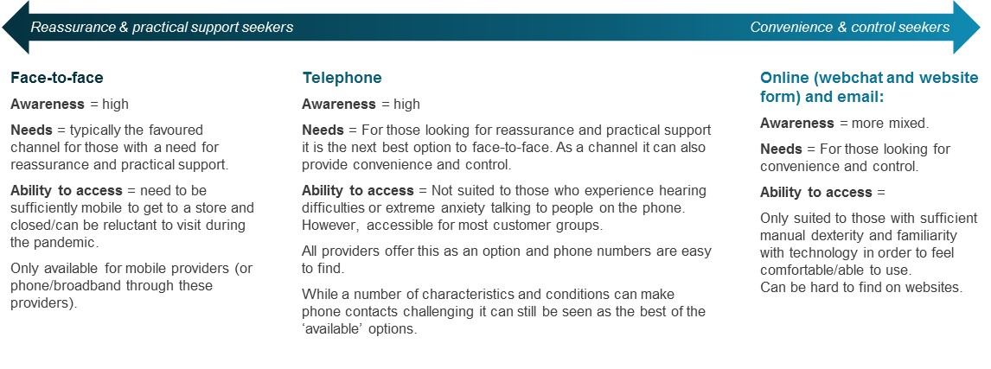
The findings of the quantitative survey support this. Across the UK adult population as a whole, 62% give telephone as their preferred method of contact when getting in touch with providers. This is detailed in chart 1 overleaf.
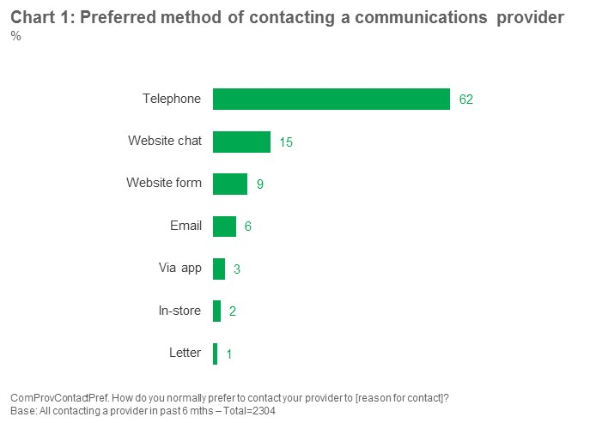
The preference for telephone contact is even stronger among those contacting their landline provider (80%) and among those contacting a provider of multiple services (70%).
Some of the PAR groups are more likely to say telephone is their preferred channel: those aged 75+ (72%), those who go online infrequently (79%) and people with a disability (68%).
As far as preference for the other channels is concerned, the following differences emerge;
- Customers contacting their broadband provider are more likely than the average to state a preference for webchat; 18% versus 15% among the total sample.
- Customers contacting their mobile provider are more likely than average to state a preference for in-store; 7% versus 2% among the total sample.

Recent contact with providers and the incidence of customers not being able to use their preferred channel
3.3.1 Recent contact with providers
Just under half (44%) of UK adults in the research have been in contact with one or more communications providers in the past 6 months. Contact has been more prevalent among those who have been finding it difficult financially, just over half (51%) of whom have been in touch with a provider in the past 6 months. Contact has been less prevalent among those aged 75+, just over a third (37%) of whom have been in touch with a provider in the past 6 months. This is illustrated in chart 2 below.
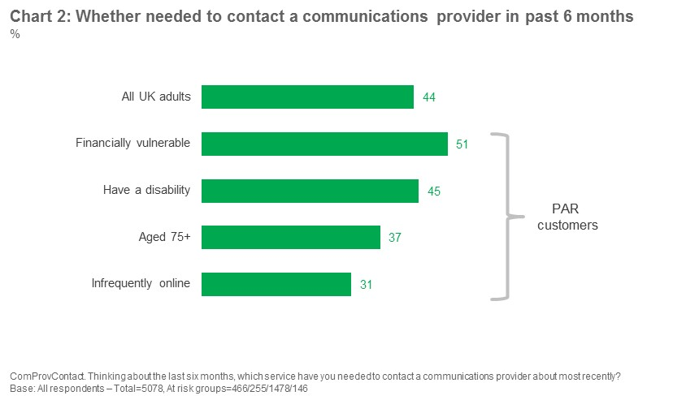
Customers have most frequently been in touch about their broadband services, or mobile services (42% and 29% respectively of those that have been in contact in the past 6 months). This is detailed in chart 3 overleaf.
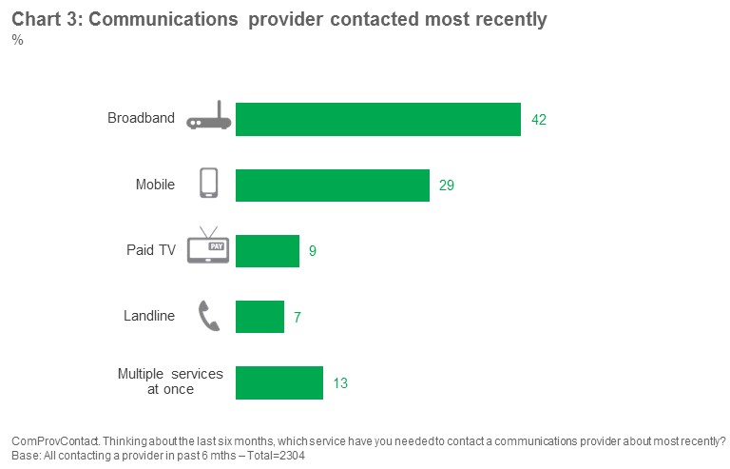
Among the PAR customer groups; older customers and those who are infrequently online are more likely than average to have been in touch with a landline provider and less likely to have been in touch with a broadband provider. Older customers are also less likely than average to have been in touch with a mobile provider.

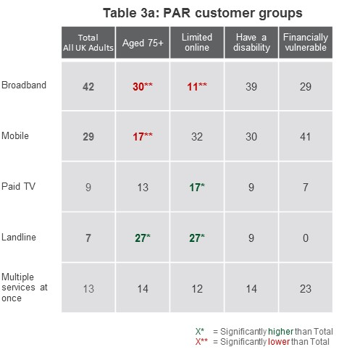
The most common reason for making contact is a need for technical support, or to report a fault; one third (34%) of customers have contacted their provider for this reason. A further 30% have got in contact to add to the services they receive. This is detailed in chart 4 overleaf.
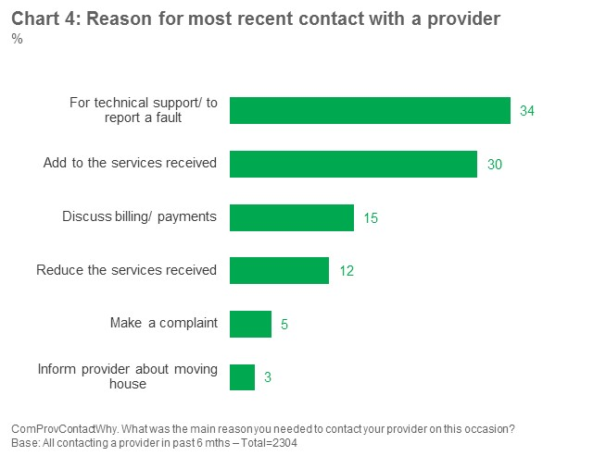

3.3.2 Incidence of not being able to use preferred method of contact
Customers in the quantitative survey were asked whether they had been able to use their preferred channel on the last occasion they contacted a provider, and also whether they had been unable to use their preferred channel at any point over the last 6 months.
Chart 5 overleaf combines the responses to these two questions to give the full picture amongst those who have contacted a provider one or more times over the past 6 months.
Across the UK adult population involved in the research as whole, just under half (46%) have been unable to use their preferred method of contact at some point over the past 6 months. Just under one third (30%) were unable to do so on the last occasion for contact. This means that over half (54%) of those who have been in contact with a provider one or more times over the last 6 months have been able to use their preferred method on all occasions and the majority (70%) were able to use their preferred method on the last occasion for contact.
Among the PAR customer groups, the financially vulnerable are more likely to have been unable to use their preferred channel. This is also detailed in chart 5 below.
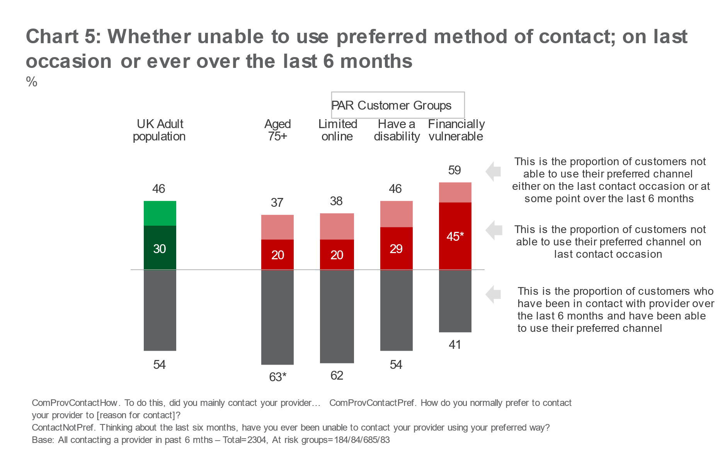
The customers we spoke to in the depth interviews report that if their preferred method of contact is unavailable, they tend to choose what seems to them to be the next best thing, depending on whether their need is for reassurance and practical support or ‘convenience and control.
This is illustrated in the diagram overleaf which shows that:
- Those who prefer in-store tend to migrate to telephone if in-store is not available
- Those who prefer telephone tend to migrate to online if telephone is problematic for any reason (particularly when in-store is not available)
- Those who prefer online tend to migrate to telephone if online methods are difficult to access for any reason.

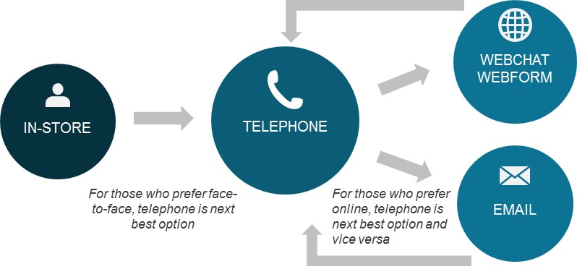

“I’d probably say going in store is my “go to”… then going onto the phone, then webchat is usually lastly preferred… It just seems like such an AI response… it’s quite long-winded sometimes.” Male, 22, Reduced hours/furloughed/redundancy due to Covid-19
“In-store is my preference as it is convenient just to pop in but they are closed so I tried telephone. That was unsuccessful … the wait times are too long … about 20 minutes I think … so I tried email but the response I got was to use their webchat service. I tried that but that wasn’t successful either as I was speaking to a robot” Male, 72, low digital skills
This overall pattern of migration across channels is borne out by the quantitative survey. Chart 6 below shows, across the UK adult population who contacted at least one communications provider in the past 6 months:
- The proportion of customers who were able to use their preferred method of contact on the last occasion for each of the channels
- Among those who were unable to get in touch using their preferred method of contact, which channel customers chose as an alternative.
So, for example, the first column on the left is based on customers who gave telephone as their preferred contact channel. The bar above the horizontal line shows those that prefer to use the telephone and were able to use this channel the last time they got in touch with their provider. Among those who were unable to use the telephone, the bars below the line show the method of contact they opted for instead (in this case predominantly webchat or website form shown as dark and pale blue segments).
The chart demonstrates that the proportion of customers able to use their preferred channel is highest amongst those who prefer to use telephone (86% of those whose preferred channel was telephone were able to use it on the last occasion). Of those who prefer to use a website form, over half (58%) were able to use this channel on the last occasion. Across the remaining channels, fewer than half were able to use their preferred means of contact on the last occasion.
Where customers are not able to use their preferred method, they most commonly opt to use the telephone instead (consistently shaded in purple across all the preferred means of contact). Thus, not only is telephone the preferred option overall, it is also the most popular second option among those who are unable to use their preferred channel.

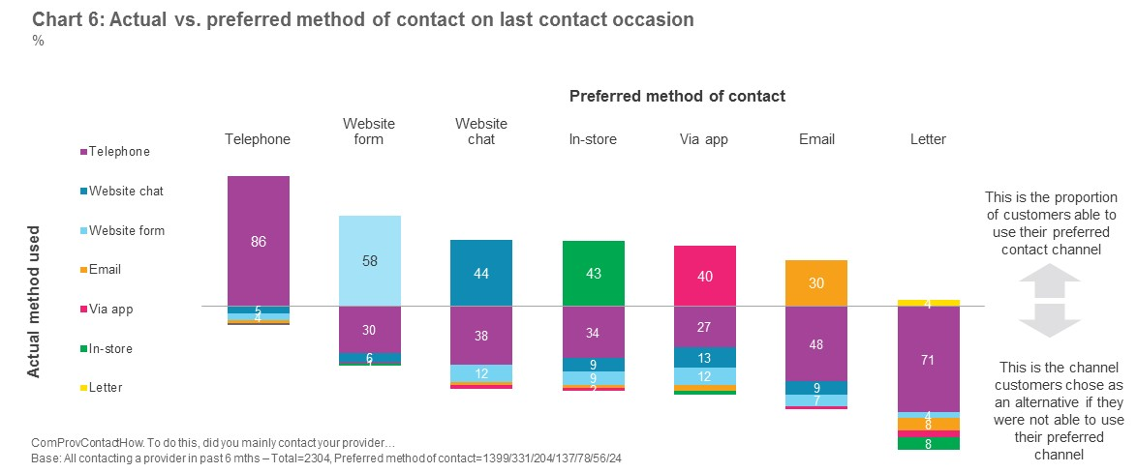

Almost all customers we spoke to in the depth interviews report that waiting times when telephoning all types of providers have increased during the pandemic and that this includes communications providers. Some have experienced waiting times of up to an hour. Response times to emails are also felt to have been slower, and customers also report longer pauses between webchat replies than previously experienced.
These experiences could prompt customers to switch to an alternative channel, even though they then sometimes found this alternative less convenient.
“I think I was on for a good 20 minutes, about that. I think it tells you you’re in a queue… I thought it’s going to be quicker to try and do something a different way… I just went onto the app after that. I thought there would be something on there, and there is – but it just sends you to the website.” Female, 44, mental disability, physical disability
“At the moment you can’t get through to anyone as all the companies have less people because of COVID … I tried to ring them (mobile provider) but I was waiting for 40 minutes and I thought my life is going to end so I came off.” Female, 32, English as 2nd language
Reasons for being unable to use face to face channels are obviously quite different, driven by stores either having been closed during a period of lockdown, customers being required to shield and/or customers having been nervous about visiting a store during the pandemic. Concerns around the health risks of going in-store are particularly rife among those who consider themselves vulnerable to Covid-19 even if they are not required to shield.
These findings are supported by the quantitative survey, where the most frequently cited reasons for customers being unable to use the preferred method of contact were the long wait times/not being able to get through, or the provider not offering that channel. This is shown in chart 7 below.
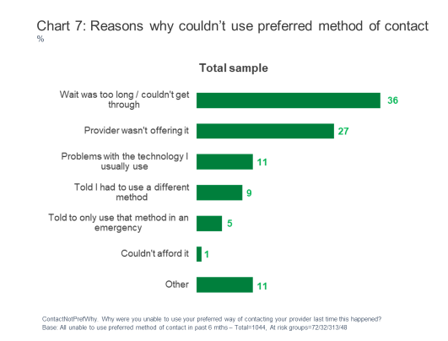

3.4 Impact of not being able to use the preferred channel
The impact on customers of not being able to use their preferred channel is highly variable. Reassurance and practical support seekers struggle most to cope with an alternative channel and therefore tend to be most impacted by their preferred channel being unavailable to use. Convenience and control seekers tend to be better able to cope and are therefore less impacted overall by switching to an alternative channel.
3.4.1 Reassurance and practical support seekers who prefer in-store but used telephone on the last occasion
These customers often find the experience of speaking on the telephone more stressful and difficult than going into a store. There are several factors contributing to this.
Wait times
These customers often find the waiting times longer than they are used to in-store. Those with anxiety issues, or who are low in confidence, often find these long wait times hard to cope with.
This stress is exacerbated when they are not told how long they can expect to be waiting and by the repetitive background music or ring tone. Customers report that when they go in-store there may be queues, but they can watch the queue progressing and have more to distract them while they wait.
Understanding
Some customers find it harder to make themselves understood over the telephone and also to understand what the call handler is telling them.
This is especially the case if they struggle with technical terms or if they and/or the call handler has a strong accent. Customers with strong accents themselves also feel it is easier to make themselves understood if they are face-to-face.
“I was glad to get off the line because it was embarrassing, aye very embarrassing, because he couldn’t understand me and I couldn’t understand him.” Male, 56, low digital skills
The same is true for those with hearing loss. Again, these customers feel it is easier to follow what is being said face-to-face (or at least when you can see the other person talking, as in a video call).
“It’s harder as you get older, like when I was younger it was fine but as I am getting older, it’s as if my mind is not taking it in. Maybe if I’m talking to someone face to face and they have an accent I can sometimes make that out better but because you are not face to face it’s kind of hard to take it all in.” Female, 67, Physical condition
Rapport/connection
Some find talking to someone over the telephone more stressful than talking to someone in store because they are less able to create a sense of rapport which, in turn, can help to build their own confidence.
“In truth you probably can’t replicate it; you are talking to an anonymous person in a call centre; you are nothing to them whereas in the shop you are a potential customer.” Male, 74, low digital skills
They can also find the customer service experience over the telephone less flexible. It can have more of a ‘scripted’ feel, which is at odds with their need for an empathic and personal contact experience. Some also feel that there is more variability in staff quality in call centres than in-store, where they feel all staff offer similar levels of empathy and helpfulness. This uncertainty can reduce their confidence in using the channel.
“So I gave them a ring and I was on the phone to a guy now and he was saying how he couldn’t find any record of me asking for it be cancelled… so he said what I can do is cancel it but I won’t be able to remove the payment for the products because it’s been a month – so why am I going to be paying for something I’ve not even used… at this point I was getting pretty frustrated because he was just saying I can’t find any records and I was saying you need to look properly so eventually I just hung up at the time. So I called up again and I spoke to someone different now… she just sat there and listened and let me get it all out… she was able to find it [the notes] and she put the credit into my account… so she sorted that out and asked me if I needed any more help and I said no thanks you’ve basically fulfilled everything I’ve needed thank you very much.” Male, 22, reduced hours due to Covid-19/furlough
Finally, some reassurance and practical support seekers who prefer in-store but are using the telephone can struggle to absorb and understand larger quantities of information over the telephone - for example, the features of several new contract options, or having to follow instructions to fix a router problem.
Practical support
For these customers the lack of practical support can leave them floundering. They are used to being able to go into the store and ask staff to do things for them - for example, to set up their new phone, swap a new SIM for an old one or even discuss an issue with their landline or broadband.
They can also struggle without being able to see and handle new mobile handsets, particularly if they also find it difficult to view the phones online. This makes them very reliant on the call handler to select the right phone for their needs, and leaves them uncertain until the new phone arrives.
“If I’d gone into the store, I’ve done so twice before and both times they have sorted me out and I’ve probably been in there for about 40 minutes because I have to wait for a bit for my turn you know, then they bring everything up on screen, they don’t hurry you and they ask if there is anything else they can help you with. If you are buying a new phone, as I was on one occasion, they will transfer the data across for you rather than saying press ‘you switch’ or whatever. They’ll do it all for you, it’s a really good service.” Male, 74, low digital skills
Practical support in the form of a face-to-face visit from an engineer can also be welcomed by those who struggle to fix issues for themselves. This can be difficult to obtain at any time (without the risk of potentially having to pay) but is felt to have been particularly difficult during the pandemic.
Confidence in the outcome
Reassurance and practical support seekers who prefer in-store but are using telephone can leave the call feeling unsure they have achieved the outcome they need. They can remain uncertain and anxious until they get reassurance of the outcome, for example:
- Their new phone arrives and it is suitable for them
- The written contract/cancellation confirmation comes through.
3.4.2 Case studies; reassurance and practical support seekers who prefer in-store but had used telephone on the last occasion
Case study 1: Prefers face to face but required to use the phone, able to resolve her issue but it took longer
The consumer: ‘Janet’, aged 67, lives with her son in Scotland.
She lives with Cerebral Palsy which means she is unable to use her right arm, she has recently had an operation for cancer and has a heart condition.
Channel Preferences: Prefers to use face to face as can struggle to understand people on the telephone and also finds they struggle to understand her own accent. On her most recent contact to her landline provider, to fix a fault, she had to use the phone due to stores being shut. Her landline and broadband are with her mobile provider and she normally gets her son to drive her to the store to chat through any issues as she can find it harder to communicate on the telephone.
She also struggles when it comes to fixing faults herself on the telephone, as physically she is often unable to do what is required. If she finds it too difficult, she has to wait and call back at a time when her son is there. She would prefer to have an engineer come out to resolve the issue.
Contact Experience: On the first phone contact they struggled to understand each other so she asked to speak to someone else. She tried to repeat the issue to the second person but they also struggled to communicate so she asked to speak to the supervisor. The supervisor then called her back approximately an hour later.
The supervisor asked her to check her connection which she did after telling them it might take a while as she might struggle. It was eventually fixed by them sending her a new ‘modem’ which her son set up for her and the landline phone is now working better.
Impact of not being able to use the preferred method of contact: She felt that it all took longer than it would have done face to face (she estimated it took two hours in total), she found the experience ‘stressful’, and was not confident it had been sorted until the new ‘modem’ arrived. She felt it would have been quicker and easier face to face as you “know who you are speaking to in the shop”. She also had to stand up during the call due to where her landline is which she finds tiring and she doesn’t use her mobile due to not getting very good reception in the house.
“I’ll say ‘I’ve got Cerebral Palsy’ and they say ‘what is that’ and I say ‘I cannae use my right arm’. They say ‘right that’s fine’ and then they go and ask you to hold one button in and press that button and use the remote control. Och it’s a nightmare!”

3.4.3 Reassurance and support seekers who prefer to use the telephone but had used webchat
The reassurance and practical support seekers that we spoke to in the depth interviews, whose preferred channel is telephone, generally started out trying to use the telephone but abandoned the channel due to overly long wait times or occasionally because the provider requested they use an alternative. The alternative they chose was often webchat.
“I’d been calling them and calling them and not really getting through. So with the webchat once they are like free on the line it gives you a little ping and then you can actually interact. I find it annoying to listen to [the ring tone on the phone], I don’t want to listen to, waiting for someone to come on the line.” Male, 51, mental health disability, financially vulnerable
The experiences these customers report with webchat are quite variable. They tend to be seeking some of the rapport and reassurance they can get from the telephone and want the webchat to feel like they are chatting to a ‘real’ person who can help with their issues.
On this basis, some customers are pleasantly surprised by how interactive the experience is; they report that it feels like a ‘real’ conversation and the chat handler can come across as friendly, helpful and ‘human’. The written record at the end of the contact can also add an additional layer of reassurance for these customers.
However, some customers find webchat unsatisfactory. In these cases, they describe feeling like they are chatting with a ‘robot’ as they get automated responses that do not resolve their issue. In these instances, webchat can feel like a somewhat remote and distant experience.
In addition, those less confident in using webchat can be put off by long pauses between answers. These serve to increase their anxiety as they wonder what is happening and whether the chat handler is still there:
- One customer, who had mental health issues, mentioned an occasion where the chat ended because they had gone away from the chat (finding the wait too stressful) then had been ‘cut off’ as they had taken too long to respond
- On another occasion a customer put the phone in his pocket so he didn’t have to keep staring at it while waiting for a response as he found his anxiety levels increasing.

3.4.4 Case studies; Reassurance and support seekers who prefer to use the telephone but had used webchat
Case study 2 | Prefers more personal forms of contact, had mixed
experiences in using an alternative depending on the provider (1)
The consumer: ‘Paul’ is aged 51 and lives in England.
He is builder but currently unemployed as a result of the pandemic. He is receiving universal credit but finds it hard to make ends meet. He has low levels of digital confidence.
He also has anxiety and depression; this comes and goes but when he is going through a ‘bad patch’ he finds it hard to do anything.
He has been struggling to make payments on both his broadband/TV package and on his mobile package and has needed to get in touch with both providers to renegotiate his contract/come up with a new payment plan.
Communications Channel Preferences: Looks for reassurance and support in his contacts with providers.
Paul prefers to deal with people in person. So for his mobile provider that means face-to-face and with his TV/Broadband provider that means the phone as face-to-face contact is not available. Paul finds it easier to strike up a rapport with someone when you speak to them in person. The phone is acknowledged to enable a degree of rapport, although this is not felt to be as good. Overall, he feels you ‘get a better service’ when you deal with someone face-to-face.
With his anxiety he can find the telephone stressful, particularly if he has to wait a long time on hold or while trying to get through. This can cause him to abandon the attempt. He finds things feel more relaxed and they seem more understanding of his situation in store.
He was not previously aware of webchat as an option, a friend told him about it when he struggled to get through on the phone and showed him how to use it. He may have found it difficult/been nervous to try it otherwise.
Contact Experience: Paul recently found himself struggling to pay his Broadband/TV bill so got in touch. He tried to contact the provider on the phone but had to hold too long and became anxious. A friend he was with encouraged him to use webchat. He was able to sort out an affordable ongoing payment plan and because he got a good outcome in the end he found it a positive experience. However, there seemed to be long gaps between responses which he found a bit ‘stressful’ as it ‘leaves a lot of space and time for your brain to go somewhere else’ as they didn't tell him what they were doing. He found himself putting his phone in his pocket between responses to stop himself feeling as anxious.
With his mobile provider he got behind with his payments and also got in touch with them to try and sort things out on the phone. He would have preferred to go in and deal with them in store but couldn’t with shops being closed. He felt they were ‘totally dismissive’ they said they would not discuss it with him until he brought the debt down to a certain level. He suspects they would have been more ‘empathetic’ in store.
Impact of not being able to use the preferred method of contact: With his broadband/TV provider he was able to get the outcome he needed although he felt the experience was ‘less pleasant’ than talking to someone and maybe slower because of the long delays. With not being able to go into store he was unable to get his payments down on the phone and suspects it may have been a more positive outcome in store as he finds they can be ‘less rigid’ and rule bound.
“[My broadband provider] doesn’t really have a walk in outlet and I am not really one for all this new technology so to speak, so I will make a phone call. It’s not my best method of communication but on that one [broadband provider] for me I there is very little option.”
“[Webchat] was a new experience for me; I hadn’t done it before…. It was a little bit frustrating to be honest because there was times when the person had responded to me and then I’d typed out my response and they didn’t respond for like two to three minutes so I am sitting there holding my phone looking at a screen and nothing is happening.”
“It was OK I would actually try [webchat] again. I would actually [be ok] trying it again. Hopefully the communication would be a bit more smoother. My one gripe with it is that delay.”

3.4.5 Convenience and control seekers who prefer telephone but had switched to webchat
For those seeking convenience and control when contacting a provider, their satisfaction with an alternative channel largely depends on whether their new choice of channel still enables them to achieve this.
For some customers, choosing webchat as an alternative to the telephone can be a pleasant experience. The reported benefits are similar to those seeking reassurance and support, in that there is a ‘real person’ dealing with their query and they receive a written record. However, for them the benefits of this are that it makes for a more effective contact experience and the written response can make it easier to absorb the information they are being given. Having more time to consider information before responding is also valued. Indeed, some customers conclude that using webchat feels quicker and easier than having to wait on the telephone and that they will use this channel again.
However, even those who are positive report that webchat has its limitations. In particular:
- It can be difficult to find webchat initially, and this contrasts with how easy it is to find a telephone number.
- Webchat can be seen as overly long winded and tedious for more complex queries, e.g. for setting up a new contract or getting help with a technical issue. While it works for some, for others it can be seen to require too much typing and feel like hard work to have the necessary dialogue. For these issues, a telephone call can still be considered quicker and easier.
- As with those seeking reassurance and support, these customers can also report that the wait times between responses can seem overly long at times, making for a frustrating experience.
“I was quite satisfied, I managed to get hold of them, not in the way I wanted. But they still eventually did what I asked. It was fairly easy. There were no issues with coming out… it would have been easier and quicker on the phone but at the same time there’s so much going on at the moment I was just happy to get hold of them.” Female, 44, mental disability, physical disability
“I wasn’t sure where in the world they were – would they understand my typing? The good thing was that I was able to have the TV on in the background while I waited – I wasn’t worried about background noise. But I’d only use it again if my phone was broken. I was exhausted! It took too long. Typing out words, you end up missing out words, and using text speak.” Female, 45, reduced hours/furloughed/redundancy due to Covid-19
“They had to put me through to another department on the webchat and I was a bit in limbo for a little while and I wasn’t sure if I was connected or and again that was a good 10 minutes… there needed to be something on there to let me know that I hadn’t been disconnected and there wasn’t so I just hung around and hoped I’d get on there” Female, 41, mental disability, physical disability
As with the reassurance seekers, satisfaction with webchat among control and convenience seekers does ultimately depend on the extent to which customers feel they are speaking to a ‘real’ person who responds to their issues.
“It just went round in circles … it was like chatting to a robot, which in fact it was as it actually said ‘I am a robot’ at the start” Male, 72, low digital skills
While they are happy to have the more distant contact that webchat provides, their lack of confidence means they still want to know that someone has understood their issue and resolved it.
“The phone is so much quicker – you can give your information quicker, there’re not waiting while the agent is typing….I felt I’d get further by phone. Online chat is less personal; it’s hard to get your point across and how important the situation is. I was less confident the issue would be sorted.” Female, 45 reduced hours/furloughed/redundancy due to Covid-19
3.4.6 Case studies; Convenience and control seekers who prefer telephone but had switched to webchat
Case study 3 | Emma, 32 year old mum of two, prefers phone when contacting broadband provider but had a positive webchat experience
The consumer: ‘Emma’: Has a young family, lives with ADHD, anxiety, depression and borderline personality disorder and is also financially vulnerable due to furlough.
She generally uses her mobile phone to contact communications providers – preferring to call, particularly for more complex issues, but she will use webchat if required for simple queries.
Communications Channel Preferences: She looks for convenience and control when contacting providers.
Her overall preference is to get in touch using her mobile phone because it’s free to call using her minutes, but it’s not without its challenges. She gets anxious waiting in a queue. And if she can’t use her minutes and has to pay for the call, this can add to her anxiety given her financial situation. Another drawback is that she can feel ‘bombarded’ with offers.
However, if the issue is ‘important’, she will phone as she feels she can get her point across better. She doesn’t like the ‘robot’ (IVR system) and gets agitated and anxious when it says, ‘I don’t understand, can you explain more?’, before taking her back to ‘square one’.
She will use webchat for offers and troubleshooting to avoid the queues when phoning her providers. But she finds it hard to get past the ‘robot’ and through to a ‘human’ on webchat. She also uses social media (Facebook), which she likes because the conversation is recorded in front of her to follow it better.
Contact Experience: She recently contacted her broadband provider as her broadband was constantly ‘buffering’.
She became tired of the long queues on the phone (which was exacerbating her anxiety), so she contacted the broadband provider via webchat. She found the experience ok – the adviser was friendly and sympathetic. She had to go through the ‘robot thing’ first but spotted ‘connect to agent’ and got straight through to an agent who could help. She felt a little anxious as she didn’t know how to express herself on the chat but believed she did get her point across. The issue was resolved for a very short time, although now the buffering has returned.
Impact of not using the preferred method of contact: She was able to resolve her issue with her broadband provider using webchat at the time as she was able to speak to a ‘real person’. However, the buffering has returned, and she has yet to get back in touch.
“I could ring and be perfectly fine now, but I don’t know what I’m gonna be like tomorrow. And then I’m worrying about what I’ve got in my account to pay everything because I’m on furlough….that does bother me, and I get right anxious because I need my phone on and my broadband because of my kids.”
“I just went onto [my provider’s webchat service]...It was perfectly fine... It worked. So I must have got my point across. I got it all written down in front of me, too, so you can read it through.”
“I got to an agent quicker than the phone. To be honest, I only just clicked on ‘speak to an agent’, and they said ‘you’re through to [the provider]…it was a lot quicker. Whether they are real or not, I don’t know…I hope they are!”

3.4.7 Convenience and control seekers who prefer online and were required to use the telephone
For convenience and control seekers who prefer webchat (or email), feeling compelled to get in touch by telephone can be an unappealing prospect. Some describe putting off the contact and/or having to psych themselves up to make the call. Waiting times are one anticipated stressor. In addition, those that lack confidence can find talking on the telephone with providers challenging as they worry about getting confused, and/or having to talk to someone they don’t know.
In reality, some are pleasantly surprised by the telephone experience and describe having their issues resolved quickly and easily.
“It wasn’t as bad as I expected … probably took less than an hour in total and I waited about 15 minutes to get through” Male, 27
However, some, often those who chose webchat to avoid human contact, find that their concerns are realised. They can feel as though they have lost some of the control they seek and in one case ended up initially agreeing to a package they didn’t want. They can also experience increased levels of anxiety, making it harder to focus on what is being discussed.
These customers can miss having the written record of the contact that webchat provides and can come away less certain about what was discussed as a result.
“On the email I could have looked and it would have told me, I’ve got no record of it now at all.” Female, 66, physical disability

3.4.8 Case studies; Convenience and control seekers who prefer online but were required to use the telephone
Case study 4 | Usual preference is email but had to use phone during lockdown
The Consumer: ‘Pauline’ is aged 66, married, lives with her husband in Wales. She can’t work as she is disabled due to bone cancer, which makes her physically impaired - “I can’t lift a saucepan.” She rarely leaves the house and is in bed a lot with the pain.
She finds she gets very ‘uptight’ when dealing with communications providers and ‘doesn’t know what to say’. She also lives with anxiety as a result of her condition.
She lacks digital confidence and has low confidence when dealing with providers.
Communications Channel Preferences; Pauline seeks convenience and control in contacts with providers.
She prefers email to get in touch as she can do it in her own time and has a record of what is said so this makes it easier to remember and less stressful. However, it can take a while to get a reply so when there is something more time critical, she is forced to call up despite finding the telephone stressful and challenging.
She also prefers to email providers as she struggles to hear what they are saying on the phone and on occasion gets worked up to the point that she has to put the phone down and abandon the contact.
Contact Experience: Pauline called her broadband provider recently as her grandchildren had come over and were wanting to play online but the connection was too slow. Her husband had also seen that her bill had gone up and £70 had been taken from her account and she didn’t know why.
She considered emailing but thought it would take too long to resolve the issue using email (particularly as things have been slow during Covid) and her grandchildren were impatient to get it fixed. Her grandson pressured her to call up instead. Her husband had recently mentioned that their most recently bill had been higher than normal so she also thought she could mention this on the call.
She called up the provider and found that they had somehow put her on a different package with reduced speeds. She remained confused as to why she had been charged £70, but she got put back onto a cheaper contract and in the end they resolved the slow connection issue. At her own admission she was uncertain as to what had happened and found the contact stressful and confusing. She got ‘so worked up’ on the phone as it was taking so long and she could also hardly hear. She can hear better using video calling and uses this on her mobile to chat to her family. In order to resolve the issue she had to threaten to leave the provider during the call. Overall, she found the experience stressful.
Impact of not being able to use the preferred method of contact: She got ‘very worked up’ on the call – and didn’t feel that the person on the other end of the call understood how she was feeling. The issue was eventually resolved so she was OK in the end as ‘the children were happy’. She doesn’t have the written record of what happened to help her remember.
“I hated it, first of all they say press so and so for this that and the other and I thought I haven’t got a clue what you press for that. And so I thought I would press one and you would get through to someone and it worked…it really winds me up.”
“I got so worked up it was terrible… usually when I email anyone I’m OK, not so bad, but because [broadband] was off and I had to phone them that did make it worse.”

3.4.9 Overall impact of not using preferred channel on the service experience
The quantitative survey indicates that contacting communications providers has been more problematic over the pandemic for some customers, and that this has been especially true for those unable to use their preferred channel.
Chart 8 overleaf illustrates the experiences of the UK adult population who have been in contact with a provider in the past 6 months, contrasting the experience of customers who were and were not able to use their preferred channel on the last occasion they contacted a provider.
Among those who were not able to use their preferred channel, half (50%) report that the experience took longer than expected, compared to just over two in five (44%) of those able to use their preferred channel. Nearly two in five (37%) of those unable to use their preferred channel report that it was more stressful and/or more difficult than usual, compared to one third (32%) of those able to use their preferred channel.
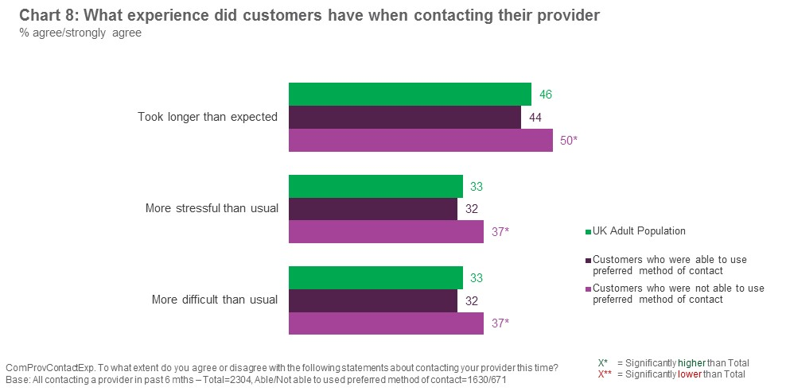

Chart 9 below compares the experiences of non-PAR and PAR customers who were and were not able to use their preferred channel.
PAR customers are more likely than non-PAR customers to report that their provider interactions have been longer, more stressful and more difficult than usual during the pandemic. Additionally, if they haven’t been able to use their preferred channel, their experience has deteriorated further.

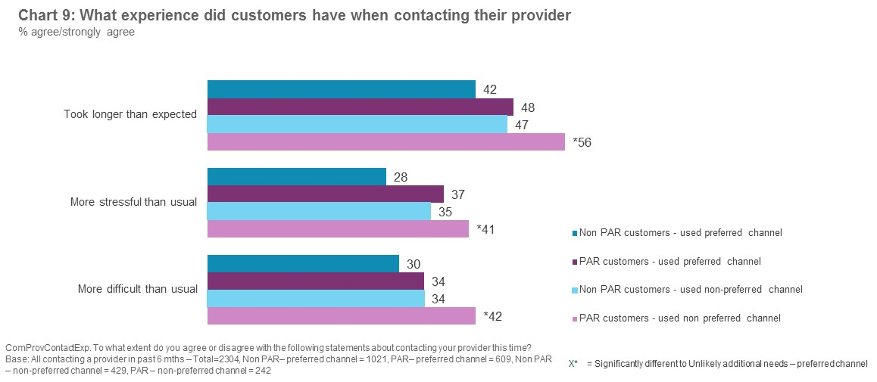

The customers that participated in the qualitative interviews reinforce this finding through what they shared about their experiences of contacting providers over the pandemic.
“Normally I’d just go to the store and I would get it sorted, but this time it felt like a real hassle, a problem” Female, 32, English as 2nd language

3.4.10 Overall impact of not using preferred channel on outcomes
As found in the quantitative research, the in-depth interviews suggest that the impact of using a non-preferred channel on the outcome of a customer’s contact with a provider is variable. While many are able to resolve their issue, others can struggle to do so, or leave the contact uncertain about the outcome.
Outcome: Resolved
For some, the issue is resolved and the experience of using a non-preferred channel is a positive one. This is more common amongst the more confident control and convenience seekers. This group may continue to use the new channel as another potential contact option once the pandemic retreats – although they tend to still prefer their original channel.
For others, the issue is resolved but the experience of using a non-preferred channel is felt to be more stressful. These customers feel they would have been able to resolve their issue more quickly and easily had they been able to use their preferred channel.
Outcome: Uncertain or unresolved
There are others who struggle to fully resolve their issue. The quantitative findings support the qualitative insight that those who are not able to use their preferred channel, and who have conditions or circumstances that can make getting in contact more challenging, are more likely to struggle to get the outcome they need.
Chart 10 overleaf reports the contact outcome of the UK adult population who have been in contact with a provider in the past 6 months, contrasting the outcome for customers who were or were not able to use their preferred channel the last time they contacted a provider.
Among those who were not able to use their preferred channel, three in five (60%) say they were able to get the information or outcome they needed, compared to just over seven in ten (71%) of those able to use their preferred channel. Nearly one in five (17%) of those unable to use their preferred channel say they gave up because they were unable to find someone to help, compared to just over one in 10 (13%) of those able to use their preferred channel.
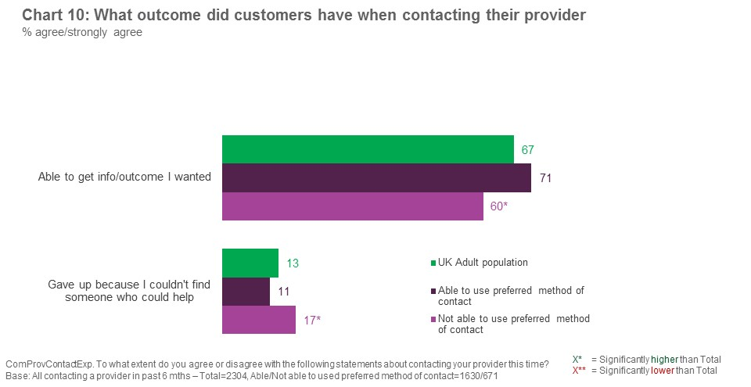
If the experiences of non-PAR and PAR customers are compared, as in chart 11 below, it is clear that PAR customers who used a non-preferred channel are least likely to get the information or outcome they need, and most likely to give up because they couldn’t find someone to help. Almost a half of these PAR customers (47%) were unable to get the outcome they wanted on their most recent contact.
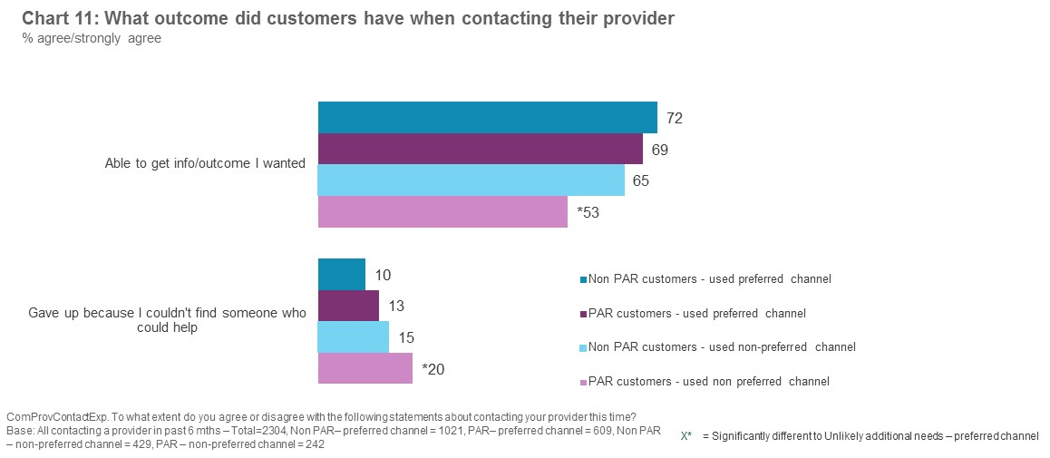
The customers who participated in the in-depth qualitative interviews reflect this in what they told us about their experiences of contacting providers over the pandemic.
Some come away from the contact experience uncertain as to whether or not their issue has been resolved. For example:
- One customer reported that they had not been able to access their online bill to check that payments have stopped.
- Once customer reported that they had not received a written confirmation of a new contract.
This uncertainty is more common among those lacking confidence, who may become overwhelmed and give up.
“I know what I signed up [for] because of what I remember, but I haven’t actually got it in writing … I might try ringing them but most probably I’ll wait and the day the stores are open I’ll be there … they are really good, they’ll show me on screen” Female, 32, English as 2nd language
In the depth interviews, some found themselves having to make multiple contacts to resolve their issues and for a minority of customers, their issue remains unresolved. They may still be trying to resolve it or they may have given up - for example, deciding to wait until the stores are open to try again. This is more common amongst reassurance and support seekers.
“I tried email and online chat but both were unsuccessful so I am resolved to waiting until the store open in April to get the issue resolved” Male, 72, low digital skills

Implications and key considerations
This section outlines the potential implications of this research for both Ofcom and Providers and also some key considerations emerging from the research.

4.1 Implications
As noted above, these implications have been split out into implications for Ofcom and for Communications Providers. They are based on the findings emerging from the research.
4.1.1 Implications for Ofcom
- It can be harder to achieve a positive outcome when preferred channels are not available. A range of factors can make it harder for PAR customers to achieve their desired outcomes – but all issues have a tendency to be exacerbated when not using a preferred means of contact. There are a number of impacts resulting from this:
  - Customers come away uncertain as to whether or not their issue has been fully resolved and whether or not they have achieved the best outcome
  - Customers may put off getting in touch to resolve issues, so they go on for longer than they should
  - Customers give up more easily and try to end the contact as quickly as possible, which can in itself lead to poorer outcomes
  - Customers are less likely to achieve their initial objectives.

- Meeting the broad spectrum of customer needs requires a range of contact channels: Customers display a number of different needs when it comes to contacting their providers. Some seek more reassurance and practical support, while others place a premium on convenience and being in control. Providers need to have a range of contact channel options available to meet these differing needs.

- Some customers are more confident and feel they get better outcomes when dealing face-to-face. Not having a face-to-face option readily available, either in-store in the case of mobile providers, or in-home engineer visits in the case of broadband/landline related issues, can mean that those requiring a greater degree of reassurance and practical support struggle to resolve their issues. With non-essential retail (including communications stores) shut during the pandemic, this has been a particularly difficult time for customers. Alternative channels need to deliver as closely as possible on the valued benefits of face to face contact.

- It becomes even more important for providers to consistently follow Ofcom’s Treating Vulnerable Customers Fairly guide during these times. In particular, providers need to find ways to identify customers who may have additional support requirements. When certain customer groups seem to be struggling to communicate effectively, not all customer service agents adapt their services accordingly. In this case there is little evidence of providers offering alternative contact channels to customers. The customer groups that find getting in touch most challenging may not be immediately apparent to providers (e.g. those with high anxiety or cognitive disabilities and/or those with low digital or literacy levels).

- Long wait times on the telephone can push customers into other, non-preferred, channels. Long wait times are particularly stressful for those customers with anxiety issues, or who tire easily as a result of their conditions or circumstances. Customers can find that their anxiety is exacerbated by being made to wait, and sometimes this means they aren’t getting the outcomes they need – or not as able to get an effective resolution as someone that doesn’t suffer from anxiety.
4.1.2 Implications for Providers
- Customers are highly reliant on service agents adapting services to their individual needs. This is true at all times but when certain contact channels are unavailable, customer services agents are more likely to be exposed to customers who may find alternative channels more challenging. These customers are most likely to feel obliged to use the telephone, and will be looking for the characteristics of their preferred method of contact to be replicated. This can include requiring more reassurance to reduce levels of anxiety and improve their chances of a successful outcome.
- Anxiety levels can also be reduced by managing expectations. Customers with anxiety can find their anxiety levels increasing when required to wait, and sometimes this means they aren’t getting the outcomes they need. The research suggests that in order to improve the likelihood of them obtaining an effective resolution to their issues, providers could do more to manage expectations.
- When face to face options are not available, providers may need to be mindful that some customers will require more practical, hands on, support. Some customers can struggle to resolve issues themselves and are looking for practical help. Where affordable and/or easy to access options (e.g. friends or relatives on hand) are not readily available, they can delay resolving issues until this support becomes available. Financial hardship can work alongside other circumstances and conditions that make getting in contact more difficult. These customers can be discouraged by concerns that they may have to pay for an engineer call out charge, even though they would benefit from an engineer visit.

- Customers who are using a channel they are less comfortable with can be less confident in the outcomes they receive. Using a non-preferred channel can make the experience more stressful for some customers. In these situations, customers report being keen to end the contact as soon as possible, as well as higher anxiety levels that make it more difficult to focus on what is being said. As a result, they seem to be more likely to come away feeling unsure/uncertain about the outcome of the contact and/or what they have may have purchased. This is particularly an issue for telephone contacts, where it is felt to be more difficult to obtain written confirmation of what has been agreed compared to an in-store or online contact. Some customers also find it easier to maintain focus using these other channels.

- Webchat can be an effective alternative for some customers but is being underutilised as a channel at present. This is due to a combination of people being less aware that this option exists and a lack of understanding as to how it works. In particular, not everyone is aware that webchat can offer the opportunity to deal with a ‘real’ person, in real time. Some also felt that providers were themselves still learning how best to deploy and manage webchat in their channel set-up.

- However, providers also need to be aware that webchat and website forms will not work for all audiences. Some can struggle to use webchat due to dexterity issues or a lack of digital skills. Webchat cannot therefore be relied upon as a back-up option for all customer groups. Those requiring more reassurance and practical support can also struggle to self-serve, so any service that delivers automated (‘robot driven’) responses is unlikely to provide the level of human support and interaction required by these people.

- Providers need to be mindful of communication barriers when using the telephone. For a variety of reasons, some customers can find it hard to make themselves understood and/or understand the call handler when on the telephone with a provider. Some can also struggle to make comparisons between different options that are available when they are presented verbally not visually (e.g. for a new package or phone). This can impact on the customer’s ability to get the outcome they needed.

4.2 Key Considerations
The following section takes each of the implications identified from the research, as listed above, and includes Jigsaw’s suggested key considerations for Ofcom and CPs emerging from this research.
4.2.1 Key considerations for Ofcom
Implication | Key consideration
It can be harder to achieve a positive outcome when preferred channels are not available. | Ofcom would remind providers of the need for customer service agents to be aware that some customers may be using a channel they are less confident with, and the implications of this.
Meeting the broad spectrum of customer needs requires a range of contact channels | Ofcom would encourage providers to promote the full range of contact options to customers, in addition to ensuring a range of options are available to suit the spectrum of customer needs.  Ofcom would encourage providers to identify customers who may struggle to use their preferred contact channels and find other ways of providing a greater degree of support to them when stores are closed (or inaccessible) and/or other channels are less easy to access (e.g. telephone due to long wait times).
Some customers are more confident and feel they get better outcomes when dealing face-to-face | Ofcom will need to keep a close eye on the impact of potential future provider store closures on the customer experience.  The research raises the question of whether mobile provider stores should be classed as essential retail in the event of a future lockdown.  Ofcom would ensure that PAR customers are able to easily obtain an engineer visit and are not put off by the concern they may have to pay. Customers over a certain age and/or with conditions impacting their mobility/dexterity may need to be offered engineer visits without the threat of a potential call out charge – and this option should be made readily available.
It becomes even more important for providers to consistently follow Ofcom’s Treating Vulnerable Customers Fairly guide during these times. | Ofcom would remind providers of the recommendation to follow Treating Vulnerable Customers Fairly Guide and in particular the need to apply these recommendations consistently. As an important first step there is a need to ensure that anyone who requires extra support can be proactively identified so that suitable help is made available.  Ofcom may wish to encourage providers to mystery shop their own performance when dealing with vulnerable customers.
Long wait time on the phone can push people into other, non-preferred, channels | Ofcom may encourage providers to find ways to cut waiting times, ideally for everyone but particularly for those where waiting might cause additional issues.

4.2.2 Recommendations for Providers
Implication | Key consideration
Customers are highly reliant on service agents adapting services to their individual needs. | Providers would consider training for all customer facing agents in how to spot customers who may require extra help and how to best adapt the service provided accordingly.  This training would need to cover the less visible conditions (such as anxiety or low literacy).
Anxiety levels can also be reduced by managing expectations. | Providers would consider putting in place measures to manage expectations, for example:  - Informing customers how long they will have to wait  - If customers are put on hold clearly explaining what is happening and how long the wait will be  - Considering more signposting during webchats so people know what to expect, especially if there are likely to be long wait times between responses (e.g. telling people when it is busy, or if the agent needs to go and get help).
When face to face options are not available providers may need to be mindful that some customers will require more practical, hands-on, support. | Providers would consider offering a range of alternative options that can bridge the gap while seeing someone face to face is not an option.  For example, alternatives such as video calling can more closely replicate the face-to-face experience than a telephone call alone.  Providers would consider sending customers links to potential deals/images of phones so they don’t have to take it all in over the telephone/while in the chat.  Providers would consider offering customers written or video format ‘how to’ guides to assist them so they can follow these at their leisure.  Providers would consider offering engineer visits to those that are struggling, ideally without the fear of a potential call out charge (especially for older, less confident customers).
Customers who are using a channel they are less comfortable with can be less confident in their outcomes. | Providers would ensure that the next steps are clearly identified at the end of any contact, including offering a written summary of the contact.
Webchat can be an effective alternative for some customers but is being underutilised as a channel at present. | Providers would promote and explain webchat as a contact option, both on the website and via telephone (e.g. a recorded message whilst waiting to get through).  In particular making it clear that there will be a ‘real person’ responding in real time, where this option is available.
However, webchat and website forms will not work for all audiences. | Providers would check that the customer can use web chat/website form options before suggesting them.  For customers that need more reassurance and support, providers would offer webchat with a live customer service agent (responding is more likely to be effective as a channel and lead to better outcomes than robot/AI driven response).
Providers need to be mindful of communication barriers for some when using the telephone. | Providers would consider putting in place things that would make it easier for customers who struggle with understanding on the telephone. For example:  - Offering an alternative form of contact that might work better for them  - The call handler adapting to speak at a slower pace and avoiding technical terms, plus being patient with the customer who needs more time  - Sending customers links to what is being discussed during the call so they have a visual not just a verbal explanation  - Having an option of a UK based call centre for those that struggle with strong accents and/or with their hearing  - Providing the option of a video call

Appendix

5.1 Background and Approach
The Communications Consumer Panel carries out research, provides advice and encourages Ofcom, Government, the EU, industry and others to look at issues through the eyes of customers, citizens and small businesses. The Panel pays particular attention to the needs of older people and people with disabilities, the needs of people in rural areas and people on low incomes, and the needs of small and micro businesses, which face many of the same problems as individual customers.
The context for this programme of research is the coronavirus pandemic. The pandemic has prompted changes in the way people engage with the telecoms industry, with a general push online as some contact centres and face-to-face outlets have been forced to close. This is likely to have left some audiences unable to use their preferred means of contact for contacting providers. The Panel was particularly interested in the impact on people who might be vulnerable due to their circumstances, including those who have recently become vulnerable due to the impact of Covid 19-19.
The scale of the problem has been measured by the Communications Consumer Panel in a quantitative survey. In addition, qualitative research has been undertaken to shine a spotlight on the needs and interests of people using specific communications channels to contact their communication provider and to illustrate what happens when people are unable to use their preferred method of contact. The research is to build a series of case studies illustrating the personal stories of people affected – or in other words the ‘human cost’ of this forced change in behaviour.
Jigsaw Research was commissioned to conduct the qualitative research which comprised a programme of online and telephone qualitative research taking place in February and March 2021. Jigsaw was also given access to the quantitative research data.

5.2 The quantitative survey
Fieldwork for this study began on the 14th January 2021 and ended on the 7th February 2021. Fieldwork was predominantly conducted using the random-probability NatCen Panel. The NatCen Panel is formed of people recruited from the British Social Attitudes (BSA) survey, a high-quality, random probability survey. Panellists were initially invited to take part online, before being contacted by telephone if they had not completed the survey after one week. A £5 gift card was sent as a ‘thank you’ to those who participated.
A total of 4,979 panel members took part in the survey of 5,931 invited to take part, giving a 84% survey response rate. Accounting for non-response at the BSA interview and at the point of recruitment to the panel, and subsequent attrition, the overall response rate was 9%. Of those that took part, 4,777 (96%) completed online and 202 (4%) completed on the telephone.
To enable coverage of the UK, additional fieldwork was conducted in Northern Ireland. A total of 100 interviews were conducted via telephone. Quota sampling was used with quotas set based on gender and age group. Further detail on the quantitative sample profile is outlined in chart 12 below.
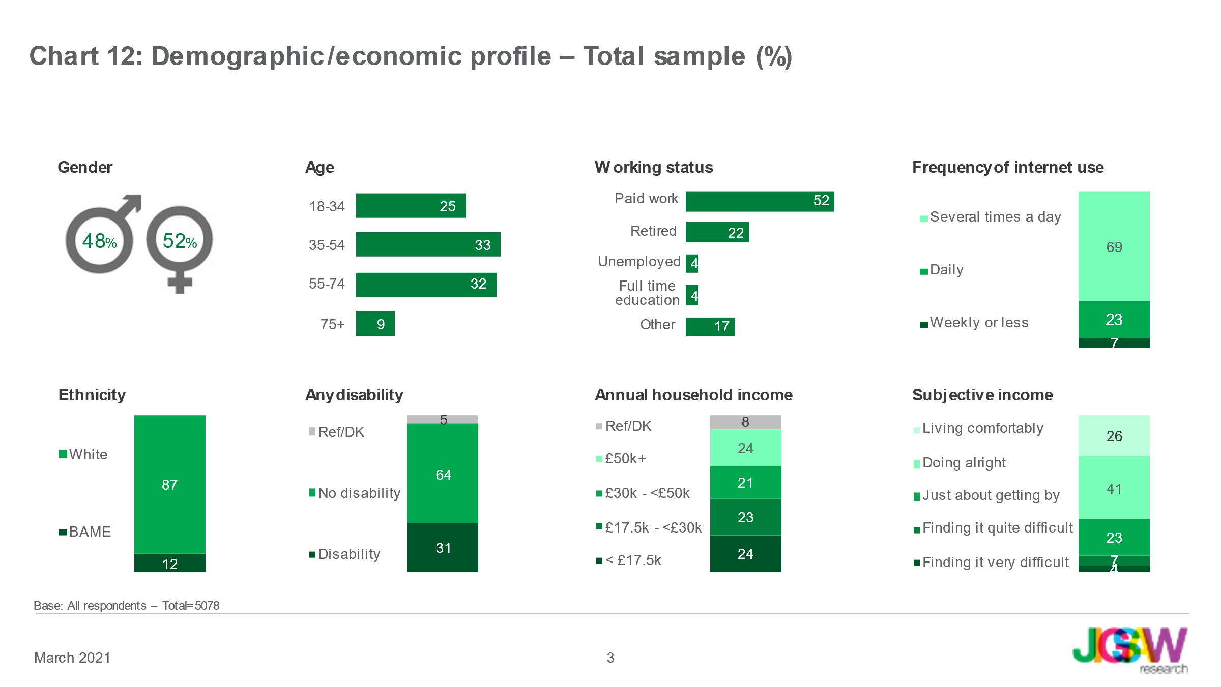

5.3 The qualitative research
The qualitative research comprised 21 depth interviews with a range of customers conducted either by video call using Zoom or by telephone. All were recruited to personally have been in contact with their communications provider in the past 6 months and quotas were set to ensure a spread of provider types, reason for contact, age, gender and reasons for having potential additional requirements.
5.3.1 Sample structure
The achieved sample is detailed below.
Sample variable | Number in sample
Gender
Female | 11
Male | 10
Age
18-34 | 3
35-54 | 7
55-64 | 3
65-74 | 4
75+ | 4
Reason for potential for additional requirements
Financially vulnerable | 10
Reduced hours/furloughed/redundancy due to COVID 19 | 3
Older (75+) | 8
Physical disability | 7
Mental disability | 4
Low digital | 5
Low literacy/numeracy | 4
English as a 2nd language | 1
Provider type recently contacted
Broadband | 8
Pay TV | 5
Landline | 0
Mobile | 11
Reason for recent contact with provider
Contract issue | 8
Technical support/problem with service | 6
Billings/payments | 4
Difficulty meeting payments | 3
Complaint | 2
Nation
England | 9
Northern Ireland | 4
Scotland | 4
Wales | 4
Urban/rural
Rural | 3
Semi-rural | 6
Suburban | 7
Urban | 5

In the in-depth interviews the potential for additional requirements (PAR) was defined using a series of attitudinal statements as follows:
- Low digital literacy: not confident across at least two statements linked to different uses of the internet
- Financially vulnerable: attitudinally agreed strongly with at least two statements linked to their financial situation (struggling to make ends meet, struggle to pay bills & struggle to understand financial information)
- Physical impairment: all experiencing a physical impairment that impacts or limits their daily activities/the work they can do (including mobility or dexterity issues, breathing, poor vision, poor hearing, speech difficulties, a physical illness)
- Mental Health issues/abilities: all experiencing an issue with their mental health or abilities that impacts or limits their daily activities/the work they can do (including learning, memory and cognitive loss as well as mental health conditions)
- Low literacy/numeracy: ‘not at all confident’ across at least three statements relating to following written instructions, reading official documents, completing forms, mental arithmetic and working out personal finances

5.3.2 Pre-Tasks
All customers were asked to complete a short pre-task exercise prior to attending the research sessions; the purpose of this was to prompt people to think about their recent contact experiences in advance of the interview itself so that they came to the interview with the details of their experience ‘top of mind’.
5.3.3 In-depth interviews
The in-depth interviews were conducted across the UK from 15th February to 25th March 2021. They lasted up to 45 minutes.
5.3.4 Discussion Guide
Overleaf is the discussion guide used for the in-depth interviews.
Jigsaw Research Limited
jigsaw-research.co.uk/
USA Office
T: +1 352 224 5994
E: info@jigsaw-research.us.com
UK Office
4th Floor, 1-2 Berners Street,
London W1T 3LA
T: +44 (0)20 7291 0810
E: info@jigsaw-research.co.uk

while people with low levels of literacy and English as an additional language were not excluded from the survey, we do not have the ability to identify them within it
Fieldwork took place in January/February 2021 – in the middle of a national lockdown.

