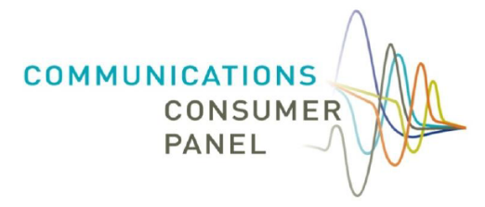

Communications Consumer Panel
& Advisory Committee for Older and Disabled People (ACOD)
Making a Difference for Telecoms Consumers:
Priorities and Work Plan
2020/21

Background
The Panel is a statutory body, established under the Communications Act 2003. Our Members, who are appointed by Ofcom with the approval of the Secretary of State, have substantial knowledge and experience of consumer issues in the communications sector and beyond.
Each year, the Panel consults on its workplan for the year ahead. In 2019/20, the Panel took forward the plans outlined in our response to the Government’s Modernising Consumer Markets Green Paper. This year, we plan to build on those initiatives that we launched in 2019/20, to continue to strengthen the consumer voice by consolidating the work of those who act on behalf of communications services consumers.

Work areas
This plan highlights areas where we intend to focus based on three criteria: where consumer harm – or the potential for it - has been identified; where the scope of the impact on consumers is significant; and where the Panel has the ability to make a difference.

Across all of these areas we will pay particular attention to the needs of people in vulnerable circumstances - who for one reason or another may be less able to participate in the market and are put at a disadvantage financially or otherwise – as well as the needs of micro-businesses.
We also describe how we plan to further enhance the voice of the consumer in communications policy development.

What we want to achieve for consumers

The Panel’s objective is to:
“protect and promote the interests of​
consumers, citizens and micro-businesses ​in the communications sector
by ​giving advice to Ofcom, industry, ​Governments and others” ​
Communications services are integral to the everyday lives of consumers, citizens and micro businesses, so their interests must be at the heart of regulation, policy making and industry practices. In a complex and rapidly developing sector this is crucial.
We want all communications consumers across the UK to be able to enjoy high quality, affordable, reliable services supported by excellent customer service whatever their needs.

Our aims for 2020/21
A high-level summary of our aims for the year ahead is shown below:

As a baseline, we believe all consumers should have the right to demand the following

from the communications sector:

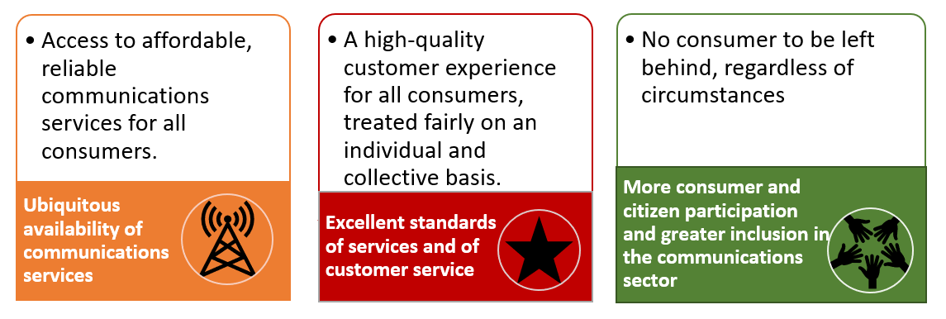
To support this, we will undertake the following activities in the year ahead:
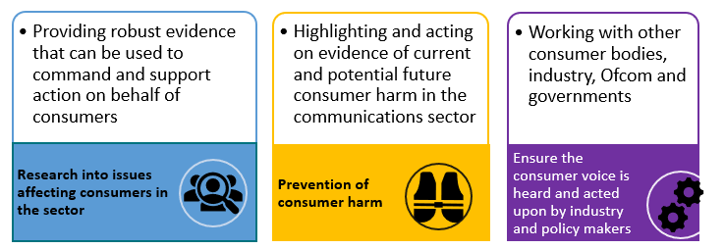
Customer charter: we look forward to seeing some tangible outcome from communications providers who have signed up to Ofcom’s Fairness Commitments. We will be working closely with communications providers and Ofcom in the coming year to facilitate this. We encourage formulation of a ‘customer charter’ by communications providers who are committed to fairness,
so that consumers know what they can expect and what will happen if they do not get it.

Who we are and how we represent the needs of consumers
The Panel provides robust and independent advice that is constructive, realistic and cognisant of the trade-offs which regulatory decisions often involve. This is made possible by the fact that Ofcom shares information and ideas with the Panel early in the regulatory process before consulting formally with other stakeholders. We are often described as a ‘critical friend’ to Ofcom. Our unique relationship, made possible by a Memorandum of Understanding, means we have early, confidential access to the regulator’s thinking and information and can proactively influence decisions by making early, robust, high quality interventions. We also provide advice to Governments, and champion consumers’ interests with industry.

We aim to ensure that the citizen, consumer and micro business voice is represented in communications policy development. Highlighting the interests of those who may not always be heard by the industry (for example, consumers in a range of vulnerable circumstances) is an important part of our role, as is working with Communications Providers, Ofcom and other policy and industry stakeholders, and consumer bodies.
Collaboration, constructive challenge and clarity of purpose remain central to our approach. We will continue to strive to ensure that the interests of consumers, citizens and micro businesses are protected and promoted, so that the opportunities offered by existing and emerging communications services are inclusive and fair, and so that the market succeeds in meeting the needs of us all. Treating all consumers fairly, including facilitating improvements in availability, accessibility, affordability and quality of service, continue to be at the forefront of our agenda.
We pay particular attention to the needs of people whose circumstances make them permanently or temporarily more vulnerable when navigating the communications market, for example; older people and people with additional needs arising from a disability; people in rural and urban areas; people on low incomes; and micro businesses, which face many of the same issues as individual consumers. Members have joint membership of the Advisory Committee for Older and Disabled People and perform a statutory role of advising Ofcom on issues relating to older and disabled people encompassing broadcasting matters such as portrayal; and access services on on-demand programming (subtitles, audio description and signing).
The Panel’s remit covers the UK and, by statute, it has members who represent the interests of consumers in Scotland, Wales, Northern Ireland and England. They liaise with the key stakeholders in the Nations to understand the perspectives of consumers in all parts of the UK so that those perspectives can inform the Panel’s consideration of issues. These members attend meetings of the Ofcom Advisory Committee for each Nation and ensure a two-way communication of ideas. Cross-membership of the Panel with ACOD was established in 2012 to improve effectiveness and efficiency.
We engage with a wide variety of stakeholders and organisations to help inform the advice that we give to Ofcom and to keep the interests of consumers, citizens and micro businesses on the agenda across the sector. Our role is to contribute expert advice to Ofcom and others based on a trusted relationship to ensure consumers’ interests are high on the agenda and we do not shrink from airing issues more widely when necessary. When we anticipate consumer detriment, or identify it occurring, we work with those who can make a difference. We are not an ex ante campaigning advocate, but we share the insights from our research publicly and make recommendations for change.

Areas of expertise
Panel members have a wide range of expertise and experience which enables them to advise our diverse work areas which cover not just all telecommunications services but also aspects of the UK postal service, and the portrayal of older and disabled people in broadcasting.
We work closely with other consumer bodies but have a unique role in ensuring that the consumer voice is heard early on in policy development, including in relation to infrastructure and the allocation of spectrum. The Panel’s understanding has enabled it to advocate for key changes that have led to significant benefits for consumers across the UK.

Positive outcomes for consumers and citizens
Our work results in positive outcomes for consumers and significant policy changes and we also shine a light on areas where communication providers should be doing better, such as customer service and complaints handling and the inclusive design of processes, products and services.

In recent years, our independently commissioned research has been well-received by industry, consumer bodies, charities and policy makers, providing insights into situations such as:

- Low-income households’ reliance on communications services:
- Consumers’ access to broadcast and on-demand content, including subtitling, audio-description and signing;
- Consumers’ concerns over data privacy;
- Meeting the needs and requirements of older and disabled telecoms consumers, and
- Consumers’ and micro businesses’ experience of problems and complaints with communications services
Our sector specialism and expertise mean we can challenge in a constructive environment, offer comprehensive advice and influence the development of policy so it delivers for consumers and citizens. We publish information about our advice and activities on our website http://www.communicationsconsumerpanel.org.uk

Wider context
Given our role as a ‘critical friend’, it is vital that we take into account the work to be undertaken by Ofcom in the coming year, as well as wider developments in the area of communications in the UK and beyond.

Our work plan is informed by Ofcom’s priorities and workstreams, as outlined in its Annual Plan, in addition to other significant developments that will affect consumers, citizens and micro businesses in the UK.

The fast-changing communications sector means that we must build flexibility into our plans in order to be responsive to new challenges. We will continue to monitor issues and liaise with a wide range of organisations representing the interests of consumers to gather – and share - intelligence about developments.

Strengthening the consumer voice in the communications sector
We outlined in our response to the Modernising Consumer Markets Green Paper a series of measures that we believed would strengthen the consumer voice across the UK. To effect real change in the telecoms sector, there needs to be much greater collaboration between consumer bodies, who can bring to bear a range of vital expertise and evidence. This can be achieved through a variety of means, enabling a stronger voice for the Nations and resulting in greater input into Government thinking and policy development. We are pleased to have enabled closer working between a wide range of stakeholders this year, consolidating and clarifying actions which should bring about tangible change in the experience of communications consumers. We are doing this in a number of ways:

- Industry Forum;
- Consumer Stakeholder Hub; and
- Hubs for each of the UK Nations
We will continue to use the insights gained from engagement across the UK – illustrated below - to improve best practice across industry and feed into policy development by Ofcom and others.

Our priorities for 2020/21

We will focus on areas where we can best effect change. As noted above, this plan highlights areas where we intend to focus based on three criteria: where consumer harm – or the potential for it - has been identified; where the scope of the impact on consumers is significant; and where the Panel has the ability to make a difference.

Based on these criteria, we have identified a set of work areas for 2020/21 which we

believe can make the biggest difference for consumers, citizens and micro-businesses:

Our proposed work areas

Our proposed work areas are set out below:

Ubiquitous availability: ensuring all consumers can access reliable, universal communications services
- Universal broadband
Area of focus: implementation of the Broadband Universal Service Obligation (USO) and interaction with coverage initiatives across the UK’s nations and regions
Issue:
2% of UK premises cannot access a decent fixed broadband service that delivers a download speed of at least 10 Mbit/s and upload speed of at least 1 Mbit/s. In Northern Ireland, this figure is 6%; in Scotland 4%; and in Wales 3%. Consumers suffer because they still do not have access to broadband speeds of 10Mbps or above. Additionally, 39,000 (0.1% of UK premises) can receive neither decent broadband nor 4G mobile coverage (rising to 3% of rural Scotland and 2% of rural Wales).
Ofcom Connected Nations December 2019
Aim: To ensure the successful implementation of the broadband USO and to secure wider broadband coverage so that consumers have the best possible access to these services. We will continue to engage with Ofcom, Government and network providers to ensure that consumers’ voices are heard in discussions about the way the USO is implemented and communicated.

Mobile coverage including 5G, domestic roaming and use of the 700MHz spectrum band
Area of focus: better coverage and better collaboration between providers – implementation of the Shared Rural Network

Issue: Mobile coverage is still worse in Northern Ireland, Scotland and Wales than it is in England. Geographic coverage varies considerably among mobile operators and remains poor in many places, with only 58% of Wales (up from 57% last year) and 42% of Scotland (up from 38% last year) able to receive 4G data services from all operators. This is in comparison with 75% geographic coverage in Northern Ireland (down from 79% last year) and 81% (down from 82% last year) in England, and 66% UK-wide.

Aim: to ensure spectrum management works for consumers so that they are not at risk of being disadvantaged by unfair commercial practices. We will work with Ofcom to encourage spectrum management policies that benefit consumers fully; and we will advocate for a “use it or lose it” policy in terms of allocation along with serious consideration of national roaming should the Shared Rural Network not deliver the required improvements for consumers.

- Universal postal services and Royal Mail
Area of focus: making sure postal services operators regulated by Ofcom provide a reliable service and treat consumers and citizens fairly

Issue: Post remains an important channel of communication for many consumers and older people remain particularly reliant on the service. Maintaining a universally reliable postal service is essential as the market adapts to new business models.

Aim: to understand the needs of postal services users across the UK and to ensure that the Royal Mail is held to account for its performance and that action is taken by the regulator if it fails to meet its delivery targets. We will continue to work to ensure that people who still rely on postal services are able to access, use and afford them.

Excellent standards of customer service for all

- Treating all consumers fairly, from pre-sales to end of contract and beyond, including Pay as You Go consumers

Area of focus: ensuring that consumers are treated fairly, are able to choose services and stay or switch without being penalised financially; urging industry and Ofcom to develop good practice guidance, in the form of a consumer charter for telecoms

Issue: Unfair practices can mean consumers overpay or do not get benefit from services to the extent that they could. Evidence relating to standalone landline prices and directory enquiries charges, as well as end-of- contract investigations, show that there are a number of unfair practices across the sector that need to be addressed. Our 2019 research ‘Don’t cut me off!” also highlights the plight of consumers in low income households, just about managing to pay their bills.

Aim: to remove unfairness in the sector so that consumers get better deals, and have greater levels of confidence and trust in the market. Work with Ofcom and providers to ensure fair and flexible policies are in place to prevent consumers in vulnerable circumstances becoming more vulnerable due to disempowering treatment by providers. We will also encourage industry to keep people in financial difficulties connected to a basic communications service to keep their lives running while overcoming payment problems. We will continue to work with CPs and provide advice to Ofcom on how to militate against unfair practices. Fair and transparent pricing and charging issues we will work on, include:

  - Differential pricing practices and personalised pricing – additional focus
on the risk of personalised servicing
  - Bundled mobile airtime and handset contracts
  - Handset unlocking
  - Non-coterminous contracts
  - Debt management practices
  - Access charges to non-geographic numbers
  - Automatic compensation across all communications services, by all providers

Excellent customer service experience for all including people in the most vulnerable circumstances

Area of focus: Ensuring that the vulnerability policies that were required by October 2018 are fully implemented by CPs and are useful, accessible and meaningful
Issue: both Panel and Ofcom research shows that customer service across the sector needs to be improved and that people in vulnerable circumstances or with additional access needs are even more significantly affected. The General Conditions strengthened the requirement on CPs to engage with the Panel on vulnerability.
Aim: As the statutory consumer panel for telecoms, we will continue to work with CPs as part of the Panel’s Industry Forum, to ensure that policies are relevant, useful, accessible and meaningful. We want to see CPs improve their culture and work to exceed the General Condition 5 requirement to provide ‘sufficient consideration’ of their customers’. We will share best practice and strongly encourage CPs to strive to provide positive, inclusive action in line with the social model of disability.

More consumer and citizen participation and greater inclusion in the communications sector. No consumer ‘left behind’:

Optimum levels of consumer and citizen participation and engagement

Area of focus: ensuring that consumers and citizens are able to participate in, and
make the most of the opportunities offered by the telecommunications sector

Issue: Across the sector, research finds that certain groups of people are more likely to
be excluded from active participation in the market in terms of:
  - Participation in the market including negotiation and switching
  - Digital inclusion and digital confidence
  - participation and portrayal of older and disabled people in broadcasting

Aim: To encourage greater participation and inclusion, whilst protecting the interests of those people who, for whatever reason, are not online; To encourage industry to run their businesses based on universal, inclusive, ethical design principles, using insights such as the Panel’s recently commissioned accessibility audit on apps.

Prevention of consumer harm

Handling of the migration to all-IP networks, from the current copper network
Area of focus: ensuring that consumers who rely on the copper network, and particularly vulnerable consumers, are supported through the switchover and do not incur extra costs.
Issue: at risk consumers may be at greater risk if migration is poorly handled; the safety of people who rely on personal alarms could be compromised if the switchover is not carefully managed.

Aim: to use our expertise to continue to facilitate discussion and encourage engagement between all parties who have a direct link with consumers most at risk, so that consumers are supported according to their needs throughout the migration process. Continuing to collaborate with the Broadband Stakeholder Group and industry to ensure the voices of consumers at risk are heard and taken into account.

Scams, nuisance calls, smishing, CLI spoofing and text fraud (and other fraudulent activity using communications networks)
Area of focus: ensuring that people, especially those consumers who rely on their landline, are able to use communications services without fear of fraudulent activity

Issue: Ofcom’s standalone landline review showed that older and disabled people are more likely to be reliant on their landline. Although volumes have decreased, Ofcom’s nuisance calls research shows that there were still at least 3.9 billion nuisance calls received in 2018.

Aim: to support initiatives on tackling scams and reducing nuisance calls and equipping consumers to protect themselves, so that the harm caused – especially to consumers in vulnerable circumstances – is reduced.

Robustness of services and resilience of networks

Area of focus: protecting consumers, citizens and micro-businesses’ access to a secure and reliable service

Issue: Outages of mobile or fixed networks can affect many millions of people and have an unacceptable impact on consumers, businesses and public services.

Aim: To ensure that network resilience remains an overriding priority for providers and Ofcom so that consumers and citizens are not subject to major disruption. We will engage with Ofcom, DCMS and providers to highlight the impact of such events and to ensure that the position of vulnerable consumers’ is taken into full account.

Provision of data to consumers to allow informed decision making
Area of focus: ensuring data that is made available is meaningful, usable and accessible to all consumers who need it
Issue: some consumers are unable, or unwilling, to engage in the communications market.

Aim: to help stimulate greater engagement so that consumers have a better grasp of the market and know how to make it work for them. We will input to guidance that Ofcom produces for CPs, engage with CPs directly and facilitate good practice discussions.

Research into issues affecting consumers in the communications sector

We will publish independent research on scams and fraudulent activity and welcome stakeholders’ views on the research areas we should consider focussing on in 2020/21.

Ensuring the consumer voice is heard and acted upon, by industry and policy makers across the UK
- Continued and strengthened interaction between the Panel and its network of UK consumer stakeholder partners in the form of:
- Consumer Hubs
- Nations and English Regions-specific Hubs
- Memoranda of Understanding
- The Panel’s independent research and a stronger awareness of the research pipelines of the Panel’s stakeholder partners.
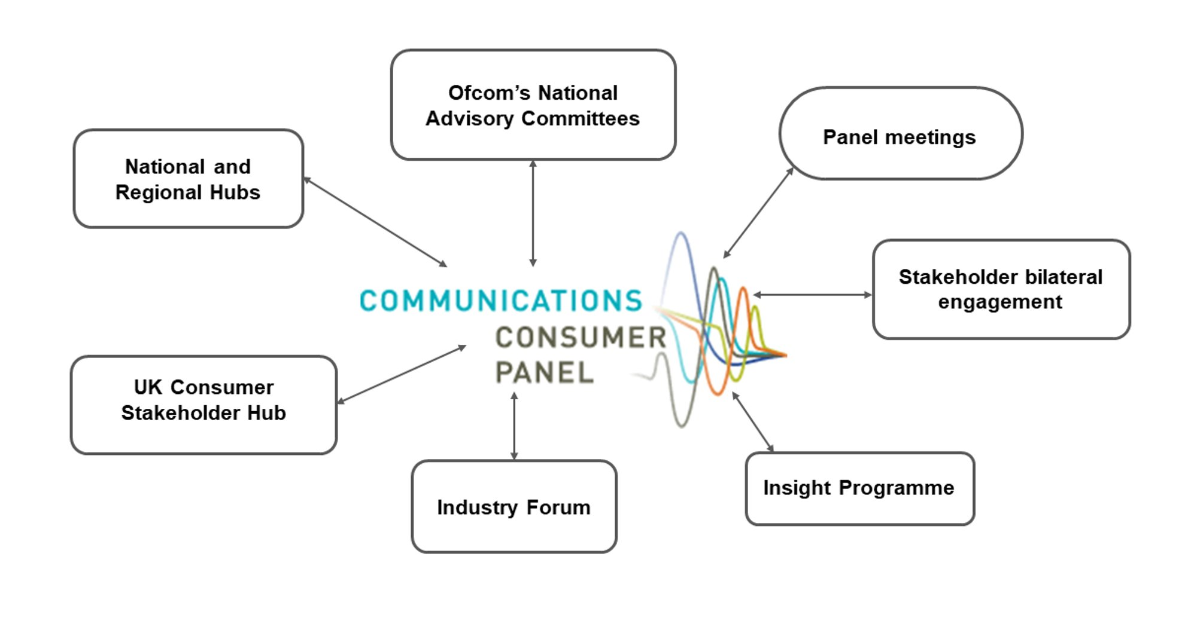
We will undertake close co-operation and explore joint working with other consumer-focused organisations on a range of issues that relate to the topics above and others that arise during the year.; For many of the areas that we have identified there are specific dimensions affecting the devolved Nations.. Our work with Ofcom’s Advisory Committees and other stakeholders in the Nations will inform our approach to these matters.

