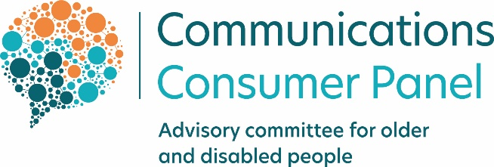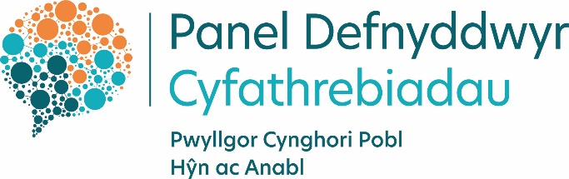

The work of the Communications Consumer Panel
and the
Advisory Committee for Older and Disabled People

Annual Report 2020/21

Contents

Foreword 3
Facts and Figures 4
Bringing together a wide view of consumers’ experiences across sectors with the Panel’s sector-specific knowledge and expertise 5
How we work 5
Engagement with our stakeholders to further strengthen the consumer voice in the communications sector 7
What we have achieved this year by listening to the consumer voice in the UK communications sector 10
Consultation responses: 18
Annexes 19
Annex 1: Text-only versions of graphics 20
Annex 2: Financial Report 21
Annex 3: Panel Member biographies 22

Foreword

It would be hard to sum up the past year without using words like ‘unprecedented’, ‘lockdown’ or ‘restrictions’. In a global crisis, it has been clear to see the positive contribution that communications providers, consumer organisations, Ofcom and the UK and devolved governments have made to people’s lives and businesses during this period, working together swiftly and collaboratively to keep people connected and informed. I have personally thanked many of the professionals in the sector for their dedication to supporting communications consumers, citizens and micro businesses during a time where they themselves were living with the same uncertainty and fears as the rest of the population.
As we move beyond that initial crisis phase, I am keen to see that collaboration, professionalism and altruism carry us into a better way forward than we might previously have thought possible. We don’t need a ‘new normal’, we need a fresh, informed approach, so that previously intractable issues can be tackled innovatively and collaboratively, to support consumers and protect them from detriment.
As Chair of the Communications Consumer Panel, I believe that fairness to all consumers – particularly those in more vulnerable circumstances – needs to be entrenched in every process, service and system communications providers operate. We believe that consumer charters will help providers to assure consumers of the high standards they can expect – and will provide a way for those providers to be held to account by consumers, Ofcom and their own Boards. We believe all consumers deserve a high quality, affordable, reliable and secure service and that this is now as important as a right to access utilities.
Some people have additional access requirements which mean they require communications providers to take note and make changes to their existing and future services, systems or processes. We have, since before the pandemic, been encouraging communications providers to improve the way they record who among their own customers requires additional support – and what is required - and have urged communications providers to make the recording of this information consistent. We hope that the communications sector will learn from the way consumer and citizen data was shared during the first lockdown to ensure that people who were shielding received priority assistance with shopping and other essential tasks.
We have seen the power of collaborating with stakeholders throughout the past year and I would like to again thank the participants of the Panel’s National Hubs, UK Consumer Advocacy Hub and our Industry Forum as well as those we meet regularly throughout the year, from Ofcom and other regulators, to DCMS, HMRC, the Home Office scams network and the Alternative Dispute Resolution schemes. Policy can take time to change, but by listening to the voice of consumers, citizens and micro businesses, we can truly aim to make the communications sector work for everyone.

Rick Hill, MBE, Chair
Communications Consumer Panel
Advisory Committee for Older and Disabled People

Facts and Figures
Strengthening the consumer voice
in the communications sector
63 meetings with 93 organisations:

National  Stakeholder  Hubs | - 14 meetings  - 71 organisations  - Our first all-UK Stakeholder Hub planned for May 2021
Consumer  Advocacy  Hubs | - 6 meetings  - 4 organisations  spanning the UK
Industry Forum | - 5 meetings  - 11 major providers  - Speakers from other sectors to build understanding of best practice
Other stakeholder engagements | - 38 meetings  - 22 stakeholders including communications providers, ADR schemes and consumer advocates

Bringing together a wide view of consumers’ experiences across sectors with the Panel’s sector-specific knowledge and expertise

How we work
The communications market is complex, highly technical and fast-moving - and impacts across society and the economy. As a result, the Panel and ACOD’s work is diverse and broad, covering not just telecommunications such as broadband, spectrum (mobile and TV airwaves) and mobile, but also post, broadcasting and issues such as digital inclusion.
The Panel’s wide remit enables it to identify sometimes diverse projects that are apparently unrelated but raise similar consumer issues and ensure that there are connections made between them. Our sector specialism and expert experience and understanding allow us to robustly challenge telecoms policy development from a position of strength, supported by sound evidence and resulting in pragmatic actions based on real world solutions.
The Panel works to influence before, during and after policy development – through a variety of methods and channels. Our work results in significant policy changes - we contribute expert advice to ensure consumers’ interests are high on the agenda and we do not shrink from airing issues more widely when necessary.
Framed by the urgency and scale of the pandemic and the resulting action by industry, regulators and governments to keep people connected, we have worked more closely than ever with our UK-wide consumer stakeholder base, listening to their insights, building them into our strategic plan, and feeding them through to those who could directly make a difference.
The sector presents different challenges to those in utilities such as energy and water; in many ways it is closest to financial services in its complexity, vast range of providers and related competitiveness. Overall indicators of consumer satisfaction with the market risk masking individual service variations. An appreciation of the complexities of the market is vital if progress on consumer service is to be made – different services within the sector present different challenges. Panel Members’ own insights from their work in other sectors, as well as the insights gained from our consumer research and our National Hubs and Consumer Stakeholder Hubs, help us to keep aware of the differences and similarities in consumer experiences across sectors.
When we anticipate consumer detriment, or identify it occurring, we work with those who can make a difference – Ofcom, communications providers and UK and national governments. Our sector specialism and expertise mean we can challenge in a constructive environment, offer robust advice and influence the development of policy so that it delivers good outcomes for consumers and citizens.

We develop our strategic plans by examining issues and considering:
➢ What is the scale of the issue for consumers, citizens and micro businesses?
➢ What difference can the Panel and ACOD make?
Our strategic aims for 2020/21, decided after public consultation are set out in diagram one, below, including a text-only version provided for people who do not process information visually:
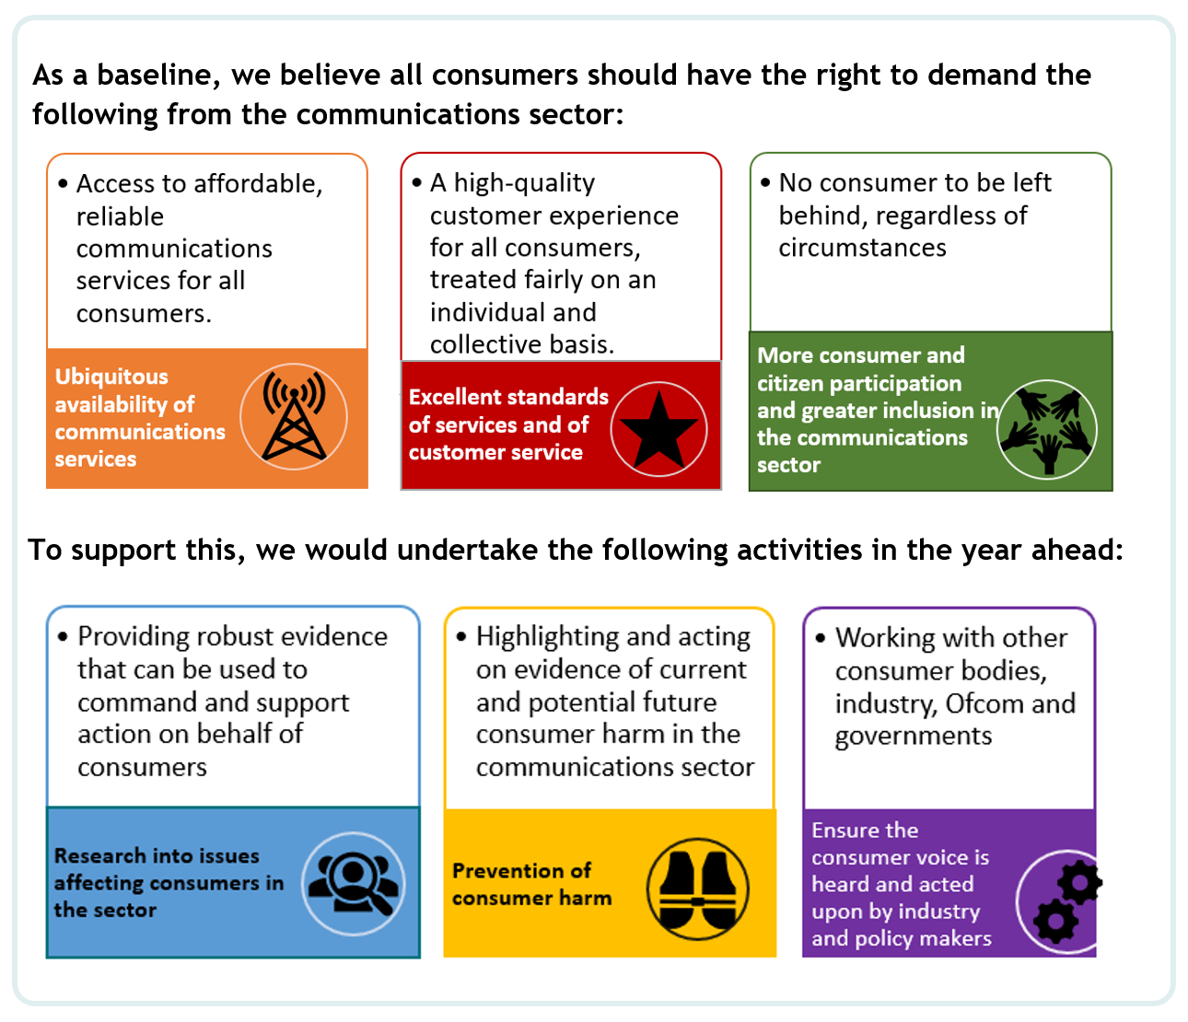
(A text-only version of diagram one can be accessed in annex 1 by clicking here or going to page 20.)

Underpinning all of these objectives, we believe there are three key elements which we have helped industry, regulators and governments to address:
- Access to and usability of broadband and mobile services in all parts of the UK - the essential nature of communications services and the impact of not having access or lacking digital skills and confidence.
- Fair treatment of all consumers, citizens and micro-businesses whose lives are touched by the communications sector - with a focus on inclusive design to ensure that all consumers, including people with additional access requirements, receive what they require to enable them to use communications services to their best effect.
- Protection of consumers, citizens and micro-business from current or potential harm.

Under the above headings, we have advised on a range of issues (this is not an exhaustive list):
- Customer service, complaints and unreported dissatisfaction;
- Rural and urban connectivity gaps;
- Switching and consumer choice;
- Micro-business service needs and difficulties;
- Accessibility and inclusivity of television and on-demand services;
- Scams and fraudulent practices using communications networks;
- Affordability and debt, with a particular focus on encouraging industry to provide and publicise the support available to financially vulnerable consumers
- Migration to voice-over IP networks (VOIP), particularly raising awareness of the implications for consumers with additional access requirements or who do not currently have broadband access;
- Portrayal and representation of consumers who may traditionally be grouped into categories such as ‘older’, ‘disabled’, or ‘vulnerable’, to encourage use of the social model of disability and promote awareness of access requirements rather than medical labels;
- Premium rate telephony services, including directory enquiries and call connection services

Engagement with our stakeholders to further strengthen the consumer voice in the communications sector
By the end of the year 2019/20, we had put in place all of the initiatives we had proposed to strengthen the consumer voice in the communications sector, and in 2020/21 we continued to adapt these to ensure we hear from those who are less likely to be heard in the development of communications policy. Ensuring that we have a diverse range of voices and perspectives across the Hubs means that we capture a well-rounded and representative consumer voice, gathering first-hand valuable information from consumer-facing organisations. Over the past year, our discussions have allowed us to capture the issues facing consumers across the UK. We have incorporated the intelligence gathered, where relevant, into our consultation responses and combined it with evidence from our insight programme to inform our advice to Ofcom and government on policy affecting communications consumers.
Diagram 2: The Panel’s stakeholders: click here to be taken to the annexes for a text-only description of this graphic (page 20). Key points are highlighted in the next paragraphs.
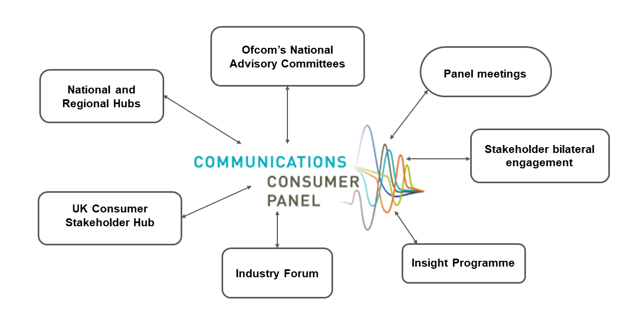
We look at each of these initiatives in more depth later in this report, but in summary:
Through our National Hubs, we have been able to deliver on our promises to gain fresh insights about issues affecting consumers, citizens and micro businesses from across the UK - that are particular to each Nation and those that are experienced universally. We have taken those insights to Ofcom’s policy teams and into industry and have seen positive action taken, which we have fed back to Hub participants. We have also acted as a facilitator of debate and encouraged information sharing. We have been pleased that Hub participants have gone on to share research and ideas with other participants following meetings.
A wide range of consumer, citizen and micro businesses related organisations have engaged with us, including those representing farming and rural communities, older people, young people, racial equality, mental health, carers, people with disabilities and many intersections of the above. We have established four Hubs across the UK – one in each Nation. The Hubs have enabled us to increase our impact by capturing the voices of citizens, consumers and microbusinesses across the UK, identifying areas of consumer harm and feeding these back to the regulator and communications providers to help drive-up best practice and improve the experiences of consumers in the communications sector.
Since mid-March 2020, we have held all meetings online. Despite the challenges of virtual discussions, we have seen the positive effect of increased attendance and growth of the membership of our Hubs in all parts of the UK. We have provided access support for participants who need it (e.g. speech to text and captions).
We have worked collaboratively with other consumer organisations – Citizens Advice and Citizens Advice Scotland, the Consumer Council for Northern Ireland and Which? in Consumer Stakeholder Hubs. These have enabled us to learn from those who have direct engagement with consumers on a daily basis, and for all participants to share insights and research plans, so that we ensure that we are working together in a way that makes the most of our differing remits, ultimately further aligning our activities to benefit consumers, citizens and microbusinesses in the communications sector. Outside of these meetings, we meet regularly with participants on a one to one basis to follow up on areas of mutual interest.
We have also been able to work collaboratively with industry, in our Industry Forum. We have brought in a range of speakers from other sectors to raise awareness of best practice that could benefit their customers. We also continue to hold meetings between the Chair and individual communication providers to hold them to account and understand and influence their consumer strategies.
Additionally, we have continued to meet with the two Alternative Dispute Resolution Providers in the communications sector and with the Broadband Stakeholder Group, the Office of the Telecoms Adjudicator, the Phone-paid Services Authority, Digital UK, StepChange and others.
We intend to continue this programme of Hubs and other stakeholder engagement, listening to participants to ensure maintained engagement in the year ahead.

What we have achieved this year by listening to the consumer voice in the UK communications sector
National Stakeholder Hubs – we have:
- Further increased participation across the Hubs and ensured a diverse range of voices are contributing to these discussions;
- Generated and driven evidence-based discussions to feed into emerging areas of policy focus in the communications sector;
- Continued to listen to our stakeholders and drive discussions in response to their intelligence of the issues facing consumers across the UK – we circulated a short survey to our stakeholders to further understand where their immediate concerns were and planned subsequent Hubs to validate current concerns; and
- Used the Hubs as a means of gathering evidence for responses to live issues and consultations, encouraging participants to respond directly where relevant.
Chaired by: the Panel’s National Members: Rick Hill (in his capacity as Member for Northern Ireland), Amanda Britain (Scotland), Richard Spencer (England) and Sian Phipps (Wales – member from July 2020, chaired previously by former Member for Wales Karen Lewis, then Rick Hill until Sian’s appointment).
Participants
The Panel’s National Hubs were introduced to help strengthen the UK consumer voice in the communications sector. The Hubs have been attended by a wide range of consumer, citizen and small business representatives, including NGOs, policymakers, consumer protection organisations; and a range of charities representing the interests of people who are older; carers; are living with a disability or long-term health condition; are in debt; live in rural communities or are digitally excluded. A full list of those organisations attending can be found at Annex A.
It is important to us that all participants who want to participate, can. We provide speech-to-text support to Deaf participants both online and face-to-face, and endeavour to ensure that all discussions, presentations and communications are inclusive.
Details on specific Hub meetings are published on our website:
- In January and February 2021, our discussions focused on the affordability of communications services and consumer debt - click here to read a summary of our discussions. The summary outlines the key messages that emerged from our discussions and includes a list of stakeholders who took part.
- In September and October 2020, participants discussed rural connectivity and the types of issues and impacts that communications consumers living, studying or working in rural areas face - click here to read a summary of our discussions. The summary includes a list of stakeholders who took part and further information on available connectivity initiatives across the Nations.
- In December 2020, the Panel published research on scams and fraudulent activity, exploring how consumers have been targeted across communications channels. Our discussions with Hub participants on the impacts of scams on consumers, citizens and micro-businesses fed into our research recommendations. Click here to access our cover report, recommendations and full research findings.
- In early 2020, during the initial stages of the Covid-19 pandemic, we discussed the impacts of the Covid-19 pandemic on communications consumers - click here to read a summary of our discussions.

It is important to us that we utilise the knowledge and skills of participants who attend the Hubs and we encourage participants to share updates on recent work that they have been involved in. A number of participants have presented information and research as part of our discussions.
The impact on communications consumers of the Covid-19 pandemic
The Covid-19 pandemic has meant that consumers, particularly those in vulnerable circumstances, require additional protections and support. Our discussions have highlighted areas of concern in the communications sector and through discussions with the regulator, communications providers and our stakeholders, we have been able to share these insights, tackling areas of consumer detriment and driving change. We have included examples below.
- Royal Mail postal redirection/diversion – at the beginning of the Covid-19 pandemic, discussions at our Consumer Stakeholder Hub and National Hubs alerted us to the high costs of postal redirection/diversion costs. This was particularly detrimental for small businesses having to move out of multi-occupant business premises in accordance with government measures. For many consumers and small businesses, in a time of financial uncertainty, the cost of redirection/diversion was unaffordable but essential to avoid a loss of custom and income. Not only were the costs high, but Royal Mail also required consumers to sign-up for three months, six months or 12 months with cost reductions for longer periods of time. This was particularly problematic for consumers as during the initial National lockdown, there was no clarity on how long the restrictions would last. The Panel raised this issue with the regulator and Royal Mail, drawing on the need for them to respond to businesses’ difficulties during an uncertain and troubling time. Although the Panel was pleased to hear from Royal Mail representatives that customers would be offered refunds for any unrequired months, we remained concerned that the upfront cost for the service remained high. We are therefore pleased that Royal Mail has now launched a small business diversion service for businesses with fewer than 50 employees at a much reduced cost.

- Ofcom’s Stay Connected Guide in EasyRead – the Covid-19 pandemic and UK Government’s announcement that there would be a national lockdown demonstrated how essential universal digital connectivity and reliable communications services had become for consumers for a wide range of day-to-day activities, for example speaking with friends and family; using public services; working from home; food shopping and accessing healthcare. Ofcom launched a helpful ‘Stay Connected’ campaign, offering connection tips to communications consumers. We welcomed this campaign and shared the information with our stakeholders but noted that some participants raised concerns that Ofcom’s campaign might not be accessible to consumers with low-literacy levels. The Panel suggested to Ofcom that an EasyRead version would help to overcome this barrier and we were pleased that Ofcom responded, publishing an additional EasyRead version on its website.

- Availability of Text Relay UK – The pandemic meant consumers could not access services face-to-face, instead having to rely on telephone or online services. For d/Deaf and speech-impaired consumers who do not access services online, telephone services would have been their only option. Participants of the National Hubs raised concerns that D/deaf and speech-impaired people were experiencing longer than average waits to access Relay UK for regular calls. The Panel raised these concerns with Ofcom colleagues, who were aware of the issue and provided a written statement that the Panel published on its website.

- Use of British Sign Language interpreters during UK Government live broadcasts – the pandemic has reinforced the importance of public service broadcasters as trusted providers of news and information. At the initial stages of the pandemic, information was largely accessed through live daily televised updates on the BBC. We heard from Hub participants that live BSL interpretation was not consistent across broadcasters and was absent during UK Government’s daily live updates, but was available during updates from the devolved governments. The Panel raised these concerns with Ofcom colleagues, and we are pleased to note that BSL interpretation are now present during UK Government live broadcasts.

- Migration to VOIP/all-IP networks
- we have been alarmed by the low awareness among Hub participants of the significant upcoming change to the telephony network that is due to take place by 2025. This will particularly have an impact on landline-only users and users of special services such as telecare alarms. The Panel has raised its concerns with the Broadband Stakeholder Group, Ofcom, the Office of the Telecoms Adjudicator (‘OTA2’), communications providers and Openreach. We believe it is vital that organisations supporting vulnerable consumers have the information they need in time to protect vulnerable consumers, citizens and micro businesses.
UK Consumer Advocacy Hub – we have:
- Continued to share intelligence across the UK, strengthen networks and identify areas that require further research.
- Identified mutual and separate areas of concern and made best use of the resources of all participants, by learning from each other’s research and commissioning research where knowledge gaps existed or further depth of understanding was needed.
Chaired by: Rick Hill, as Chair of the Communications Consumer Panel
Participants
The UK Consumer Advocacy Hub provides an opportunity for consumer advocacy bodies to come together and share knowledge and awareness of the types of issues facing consumers nationally. We established it to help strengthen the consumer voice in the communications sector by working in conjunction with the Panel’s National Hubs and Industry Forum.
Regular attendees include: Citizens Advice, Citizens Advice Scotland, Consumer Council for Northern Ireland and Which?. The meetings provide an opportunity to share knowledge across the consumer landscape and drive awareness of any ongoing work/or research and avoid duplication of work. The meetings have been held quarterly since January 2020 (except for during the initial stages of Covid-19 pandemic where meetings were held monthly). These discussions were invaluable during the initial stages of the pandemic to share intelligence in a fast-paced and unpredictable world where consumers needed additional protections.
A key example of this collaborative approach concerned specific issues raised at the Northern Ireland Hub and by the Consumer Council for Northern Ireland (CCNI) relating to the potential effects of the implementation of the NI Protocol on parcel deliveries for consumers in NI.
In common with the CCNI, the Panel is concerned that the implementation of the Protocol could create significant consumer detriment and reduce consumer choice by creating barriers which prevent NI consumers from shopping with GB businesses. GB businesses may decide to pass some or all of the additional costs they incur from dealing with the new customs requirements onto consumers in Northern Ireland or may even decide not to sell to consumers in Northern Ireland at all.
We conducted further analysis of CCNI data which, when examined together with research by Citizens’ Advice and Ofcom, established evidence that suggested that the implementation of the NI Protocol in terms of the proposed changes to the NI customs rules risks a detrimental effect on online shoppers/mail-order consumers with disabilities in Northern Ireland over and above the detriment that may be caused to other NI consumers. We urged HMRC to fully consider the potential consumer issues created by the Protocol and where relevant, take action to reduce or eliminate any consumer detriment. We also urged Ofcom to consider the impact of the revised customs arrangements for second class parcels on the delivery of the Universal Service Obligation both in terms of delivery delays and additional charges. We have subsequently had constructive engagement with both bodies and await news of developments.

Industry Forum – we have:
- Conducted further work on defining and understanding ‘vulnerability’. We have encouraged providers and regulators to look beyond this label to ensure that consumers with additional requirements can be identified and have an equal opportunity to benefit from communications services;
- Invited smaller providers to join the Industry Forum and benefit from discussions with larger CPs, other sectors and the Panel; and
- Commissioned a think piece on making communications services inclusive: we asked an external specialist to write a report that will help us to help communications providers to achieve best practice in designing inclusive services. We sought input from industry in developing this, so that it is useful to them and our specialist interviewed a range of stakeholders including Ofcom, consumer organisations and charities, including participants of our National Hubs. We will publish the report and share it widely.
- Invited guest presenters from other sectors to broaden the imagination regarding what’s possible in terms of adapting and designing processes to suit consumers’ changing needs and requirements.

Chaired by: Rick Hill, with Panel Member Kay Allen as a special adviser and facilitator to the Forum, bringing best practice examples to help inform discussion
Participants
Our Industry Forum gathers the larger communications providers together under Chatham House Rule.
The Forum enables discussion of how to overcome obstacles and barriers to service improvement – including making their services accessible and easy to use by all consumers– notwithstanding the fact that they are competitors of each other.
Our aim is to provide a baseline level of fairness for consumers, above which CPs can freely compete for customers. In the first instance, we support Ofcom’s aim of ‘Making Communications Work for Everyone’ and to provide examples of best practice in other sectors to help inform CPs about methods to overcome barriers to this goal.
We have invited speakers from financial and payment services and the utility sector, as well as Ofcom, to speak to the Forum about the ways vulnerability can be measured– including financial vulnerability - and the services and concession that can be provided to support all consumers. We encourage providers to get to know the additional access requirements of their customer base and make it easy for all to use their services without barriers.
We have valued being able to work collaboratively with industry, in our Industry Forum and have heard that participants continue to find it helpful and worthwhile.
We also continue to hold meetings between the Chair and individual communication providers to hold them to account and understand and influence their consumer strategies.
Panel meetings – we have:
- Continued to breadthen our knowledge by inviting external presenters as well as Ofcom policy teams to present their policies, findings and projections to the Panel;
- Identified synergies between ongoing pieces of work by our stakeholders and called out issues of consumer harm early on, to prevent, reduce or halt impact on consumers and enable proper redress and straightforward signposting to take place where relevant.

Chaired by: Rick Hill
In the last year we’ve provided expert advice and guidance on a wide range of topics including:
- migration to voice-over IP (VOIP)/all-IP networks;
- switching and consumer choice;
- customer service, complaints and unreported dissatisfaction;
- premium rate telephony services, including directory enquiries and call connection services;
- rural connectivity;
- micro-business service needs;
- accessibility and inclusivity of television and on-demand services;
- affordability and debt (with a particular focus on encouraging industry to publicise the support available for financially vulnerable customers); and
- scams and fraudulent practices using communications networks.

Participants
Monthly Panel meetings are attended by all Members, who are able to prepare questions and advice for presenters and learn about emerging policies, provide consumer insights and provoke thought and debate. Members may also meet outside of these regular meetings on topics of interest and expertise.
We will continue to engage with a wide range of stakeholders, including Ofcom, the National Advisory Committees, other regulators, individual communications providers and other subject matter experts from outside the Panel and ACOD to look deeper into intractable issues that need a more proactive and systematic approach. These include the inclusivity of providers’ services to all consumers, by designing and operating their services, customer services and complaints processes fairly.

Our research and insight programme – we have:
- Published a report on scams and fraudulent activity
During the past year, we published our independent, quantitative and qualitative research ‘Scammed! Exploited and Afraid’ ￼, on consumers, citizens and micro businesses using or affected by those services.
Fraud or ‘scams’ cost the UK £190 billion a year and are closely connected with other aspects of organised criminal activity.
In addition, a third of victims of fraud have suffered a significant emotional or psychological impact as a result.
Our research presented some examples of the harm and detriment caused by these crimes and the detriment felt by the participants in their lives going forward – from a restriction in lifestyle as a reluctance to use particular communications services again, to a participant who had to take a year away from work, to recover from the stress of having unknowingly enabled skilled fraudsters to steal from their employer’s micro business.
In this time of COVID-19, people around the world have become ever more reliant on communications services and the key role that they play in people’s lives has never been more evident as we hurtled into new ways of living, working and existing. Yet, at this critical time for UK consumers and micro businesses, it appears that fraudsters have taken the opportunity to increase their scamming activities and exploit people,.
We wanted to understand more about the way scams take place across communications networks (phone, internet, email and post) and the harm they cause to consumers. We previewed the key themes of the research at our National and Consumer Stakeholder Hubs, using it as a stimulus for discussion and raising awareness of activity being undertaken by stakeholders on scams.
Informed by the research, we have made a series of recommendations which we will be pursuing further with industry, regulators and policy makers:
- Security: consumers need to feel that they can use communications services without being afraid of scams;
- Clarity: consumers need to be able to find information on scams easily; if targeted, consumers have a clear way of reporting the scam - they know who to report it to and to be able to do so in a way that suits them;
- Action: consumers have a right to expect that their report of fraudulent activity will be handled compassionately, and action will be taken;
- Monitoring: consumers need agencies to work together to measure and fix the problem and governments should provide the necessary regulatory and enforcement resources to support this.
We have shared these recommendations widely and have worked closely with stakeholders in a range of sectors who share a mutual interest in fighting fraud.
- Commissioned technical reports on the accessibility and usability of apps
As members of ACOD, Panel Members take a particular interest in the access requirements of consumers and citizens, having heard from stakeholders that apps were not always accessible for people using assistive technologies, we commissioned an audit of CPs’ self-service apps. Initially, these would be fed back to communications providers’ technical teams for follow-up and action, with the overall themes noted by the Panel further investigation.
When commissioning the reports, the unforeseen changes in the sector that would be due to the impact of the pandemic still lay ahead, with the mass closure of retail stores due to lockdown.
We undertook to commission research into the experiences of consumers whose preferred channel was not available during the pandemic, to learn what communications providers could do to help all consumers in a crisis where everyone is potentially a ‘vulnerable consumer’.
3. Commissioned robust, insightful, independent studies into the following issues:
• how people’s digital needs have evolved during the pandemic;
• consumers’ preferred channels of contact with CPs;
• the potential impact on consumers and micro businesses, of the forthcoming migration to VOIP – and how to mitigate that impact;
• the needs of communications consumers living in residential care; and
• the experiences of consumers who use parcel services.
Upon completion, each independent report will be published on the Panel’s website, with a cover report containing a summary of the findings in context, and our recommendations for action. Reports are circulated widely, to our stakeholders and beyond, via traditional means and social media.
We have been using the emerging findings from our projects in past months, by:
- Holding a research agency forum, where the agency directors and managers of our projects discussed cross-cutting findings and themes, helping the Panel to better understand consumers’ ‘pain points’;
- Hosting National Hubs on the theme of digital inclusion, confidence and skills, with presentations from Good Things Foundation and others;
- Attending the All-Party Parliamentary Group on Digital Skills;
- Hosting an all-UK Hub on migration to VOIP, with presenters from Openreach and the Scottish Digital Service;
- Meeting DCMS, devolved governments, HMRC, the Home Office, Ofcom, the Phone-paid Services Authority (PSA), UK Regulators’ UKRN, CCNI, CAS, Citizens Advice, Which? and others.

- Commissioned ‘Making Communications Inclusive – a think piece’
As highlighted under ‘Industry Forum’, we also commissioned an external specialist, Graeme Whippy MBE, to write a think piece on Making Communications Inclusive, which we look forward to publishing and using as a vehicle for change and a guidepost for those who want to make a difference and don’t know where to start.

Consultation responses:
We publish all of our responses to public consultations on our website. All responses from 2020 and 2021 can be found by clicking on the links below:
2020 consultation responses (communicationsconsumerpanel.org.uk)
2021 consultation responses (communicationsconsumerpanel.org.uk)
We have responded to consultations by Ofcom, the Department for Digital, Culture, Media and Sport (DCMS), the Gigabit Take-up Advisory Group (GigaTAG), the Consumer Council for Northern Ireland (CCNI) and the Phone-paid Services Authority (PSA), to provide the UK communications consumer voice on a wide range of topics, including:

- Mandating emergency video relay to protect British Sign Language users in a crisis (Ofcom)
- CCNI’s corporate plan (supporting its work in telecoms and postal services)
- Ofcom’s Plan of Work
- Protecting Voice-only landline customers – supporting a continued reduction in costs by providers who had been overcharging people who rely on landline services
- GigaTAG’s call for evidence on stimulating demand for gigabit-capable broadband connections across the UK
- Open communications: enabling people to share data with innovative services (Ofcom)
- Making on-demand programme services more accessible
- PSA’s discussion document on its Code of Practice (with our particular focus being fair treatment of consumers and citizens using directory enquiries and call connection services)
- The impacts of Covid-19 on the communications sector (DCMS)
- Digital comparison tools: proposed changes to Ofcom’s voluntary accreditation scheme
- Fair treatment and easier switching for broadband and mobile customers (Ofcom’s implementation of the European Electronic Communications Code)
As highlighted previously in this document, the Panel provides a voice for consumers, citizens and micro-businesses not just in public consultations, but also in regular meetings with policy-makers early on in policy development and throughout implantation and revision of policy.
We also regularly share news of public consultations with our stakeholders to encourage policy insights from a range of consumer, citizen and micro-business representatives.

Annexes
1. Text-only versions of graphics – page 20
2. Financial Report – page 21
3. Panel Member biographies – page 22

Annex 1: Text-only versions of graphics
Diagram 1: the Panel’s strategic objectives for the year that this report reflects on:
1. As a baseline, we believe all consumers should have the right to demand the following from the communications sector:
- access to affordable, reliable communications services for all consumers;
- high quality customer experience for all consumers, treated fairly on an individual and collective basis; and
- no consumer 'left behind' regardless of circumstance.
2. To support this, we would undertake the following activities in the year ahead:
- providing robust evidence that can be used to command and support action on behalf of consumers;
- highlighting and acting on evidence of current and potential future harm in this sector and - working with other consumer bodies, industry, Ofcom and governments.
Click here to be taken back to the ‘How we work’ section, or self-navigate to page 6 to continue reading.

Diagram 2: The Panel and its stakeholders
This diagram depicts the Communications Consumer in the centre of the following stakeholder engagement initiatives:
Panel meetings;
Stakeholder bilateral engagement (individual meetings);
Insight programme (our consumer research and other organisations’ research);
Industry Forum;
UK Consumer Stakeholder Advocacy Hub;
National Hubs and
Ofcom’s National Advisory Committees.
There are two-way arrows between the Panel and each of those listed above, to show two way communication and exchange of ideas.
Click here to return to the start of the section about our stakeholders, or self-navigate to page 8 to continue reading.

Annex 2: Financial Report

Panel Member Fees |  | £122,322
Panel Member Expenses |  | nil
Support (including Advisory Team, research, consultancy, stakeholder engagements, communications access support, design and website publications) |  | £515,683
Total: |  | £637, 912

Annex 3: Panel Member biographies
Information on Panel Members is kept up to date on our website, here:
Panel members - Communications Consumer Panel
Rick Hill MBE (Chair and Member for Northern Ireland)
Following degrees in Applied Maths and Church History, Rick worked as a parish minister for 17 years. He left church work in 2007 to develop a portfolio career. He is Owner/Director of Titanic Gap Ltd, Media Consultancy.
Rick has previously been Deputy Chair of the Independent Press Standards Organisation, Chair of Northern Ireland Screen Commission, Chair of The General Consumer Council for Northern Ireland, Chair of Consumer Focus Post and member of the Consumer Focus UK Board, a member of the BBC Audience Council for Northern Ireland and BBC Broadcasting Council for Northern Ireland. In 2014, he was made MBE for services to Broadcast Media.
Kay Allen OBE
Kay has worked for B&Q, BSkyB and Royal Mail. She has been a Commissioner on the Disability Rights Commission and the Equality and Human Rights Commission. She also served as a NED on the Department for Work and Pensions PDCS Board.
In 2010 she was asked by Downing St to look at Responsible Business Practice of small business as part of the Big Society Team. As a result she created the on line digital platform ‘Trading for Good’ which is now owned by Business in the Community.
She has run her own successful bespoke consultancy for 10 years specialising in Responsible Business and Diversity and Inclusion. A qualified performance coach Kay helps others to succeed. Kay is a Fellow of St Georges House Windsor, A Fellow of the Chartered Institute of Personnel and Development and a Fellow of the Royal Society of Arts. In 2010, she was awarded an OBE for services to Equality.
Amanda Britain (Member for Scotland)
Amanda has experience spanning research, public services, and organisational change in Scotland. In all roles, she has championed the interests of people who are socially or economically excluded. She is currently supporting Scotland’s national Technology Enabled Care Programme, is an advisor with Life Changes Trust dementia programme.
Amanda is Chair of Iriss, a charitable company that builds the capacity and capability of the social services workforce in Scotland, and a member of Alzheimer Scotland’s Human Rights and Public Policy Committee. She is a member of the Chartered Institute of Housing, was elected to its Scotland Board from 2012-2018 and was Chair from 2017-2018.
In parallel, Amanda has chaired the Peter Gibson Memorial Fund, which in September 2016 published 'Championing Consumers, a history of consumer advocacy in Scotland 1974-2014.'
Clifford Harkness – joined June 2020
Clifford began his career as a telecommunication and electronics technician with Queen’s University Belfast working on television production and audio resources - including linguistic research. This role led him, to the Ulster Folk & Transport Museum’s Department of Non-Material Culture where he supported curatorial staff in the development of oral, aural and linguistic sound recording and audio archiving. Clifford became Head of Archival Collections before the establishment of National Museums Northern Ireland, where he was Head of Collections Management, until early retirement in 2016.
He has an enduring interest in the impact of science and technology on everyday lives and the collection, preservation, and access to multi-media archives. He was a founding member of the then N. Ireland Film Council, the Ulster Oral History Society, and the N. Ireland Reminiscence Network.
He is a former member of the BBC Audience Council and BBC Broadcasting Council for Northern Ireland. He currently acts as a museum ‘Accreditation Mentor’ for the Somme Museum and is a member of ‘The Stories Network’, hosted by the Healing Through Remembering Organisation, for those gathering and sharing personal narratives related to the conflict in and about Northern Ireland.
Dr David Holden
David sits on the Electricity North West (ENW) Customer Engagement Group. The group is charged with challenging ENW to ensure that its future business plans address the needs and preferences of its current and future customers and that it is putting stakeholder needs at the heart of its decision making, with special reference to the forthcoming price control period 2023-2028 (RIIO-ED2)
David previously sat on the Civil Aviation Authority’s (CAA)/HAL Consumer Challenge Board (CCB), tasked with providing scrutiny to ensure that the current £15bn Heathrow expansion plans, regulatory price review and five-year business plan is driven by the understanding and prioritisation of the needs of its current and future consumers. The CCB challenges and scrutinises HAL’s business plan to determine whether it meets the requirement of ‘high quality consumer engagement’.
David has direct and extensive experience of working on large-scale consumer insight projects for Vodafone, BT, O2, EE, France Telecom, 3, Sky, Inmarsat, Talk Talk, Carphone Warehouse, Ericsson, Nokia, Virgin Media, Cable and Wireless and Alcatel.
Dr Siân Phipps (Member for Wales) – joined July 2020
Siân spent four years championing the interests of water consumers through her non-executive role with the Consumer Council for Water, regularly challenging the performance of water companies in Wales. As a Patient and Community Leader at Velindre Cancer Centre, Siân is also a voice for people who use health and care services and is currently a lay member with NICE, the National Institute for Health and Care Excellence, assisting with the development of a guideline on shared decision making.
Previously in her career, Siân worked for cross-party committees in the Senedd/Welsh Parliament and in the House of Commons, where her role was to advise Members in scrutinising government policies, legislation and finance.
Siân has worked in communications and public affairs for a range of public organisations including BBC Wales, the Arts Council of Wales and the Environment Agency, and has a PhD in public attitudes to environmental risk from the University of Leeds. Siân is a Welsh learner, originally from Cardiff, where she currently lives.
Richard Spencer (Member for England)
Richard has 30 years’ experience in consumer and SME mobile and fixed telecoms markets in the UK and abroad, most of which was spent at BT. His career has encompassed pricing, strategy, policy, business ethics and regulation. His final role was as Director of Corporate Social Responsibility, playing a key role in architecting and monitoring the company’s programmes designed to have a positive impact on society and the environment.
Richard is a Non-executive Director of the East Suffolk and North Essex NHS Foundation Trust and is trustee for a charity in Colchester which provides support to people who are homeless or at risk of homelessness. He also serves on the Leadership Board of Reference of a local church in Colchester.
Richard holds an MBA, a degree in History, and has trained as an executive coach. He is currently studying part-time for a degree in Theology.
Craig Tillotson – term ended at the end of October 2020
Craig has enjoyed a successful and varied career over the last 30 years in the telecommunications and payments industries as a business unit leader, board director, strategy consultant and entrepreneur. In 1997 he joined T-Mobile UK as Strategic Development Director. In 2001 he joined Vodafone UK as Product Management Director. In 2003 he became Strategy and Wholesale Director and in 2007 took over the leadership of the UK Consumer Business Unit.
From 2012 to 2018 Craig was the Chief Executive of the Faster Payments Scheme, the UK's world leading real-time bank-to-bank payments system. Craig was also Executive Chairman of PayM, the mobile payments service from 2014 to 2018.
In 2014 he was appointed by the Financial Conduct Authority to be a member of the new Payment Systems Regulator’s statutory Panel, where he served until 2018.
In 2018 Craig became co-founder and CEO of the Smart Request Company Ltd, a FinTech start-up business working to develop the UK's first competitive Request for Payment service.
With a degree in Computer Science, Craig spent the early part of his career as a Strategy Consultant with McKinsey & Company. For many years he was a Specialist Telecommunications Reserve Officer in the Royal Corps of Signals where he was awarded the Territorial Decoration (TD).
Rick Williams
Rick is the Managing Director of Freeney Williams Ltd, a disability and diversity consultancy. He is a Chartered Fellow of the Chartered Institute of Personnel and Development and an Associate of both Business Disability International and the Business Disability Forum.
Rick is an experienced consultant and trainer with expertise in all areas of disability and their impact on individuals and organisations.

Stay connected during coronavirus – EasyRead version (ofcom.org.uk)
https://www.communicationsconsumerpanel.org.uk/news/latest/post/745-ofcom-has-responded-to-reports-that-deaf-and-speech-impaired-people-are-experiencing-longer-than-average-waits-to-access-relay-uk-for-regular-calls
https://www.ofcom.org.uk/__data/assets/pdf_file/0010/200503/media-nations-2020-uk-report.pdf
https://www.communicationsconsumerpanel.org.uk/news/latest/post/749-our-new-research-on-scams-has-been-published
The Police Foundation December 2018
BBC article on romance scams: https://www.bbc.co.uk/news/business-52664539
Action Fraud article ‘UK Finance reveals ten Covid-19 scams to be on high alert for: https://www.actionfraud.police.uk/news/uk-finance-reveals-ten-covid-19-scams-the-public-should-be-on-high-alert-for
www.communicationsconsumerpanel.org.uk
Graeme K Whippy MBE, credentials and endorsements

